LLANTWIT MAJOR TOWN COUNCIL
ANNUAL REPORT

For Financial Year 2025/26

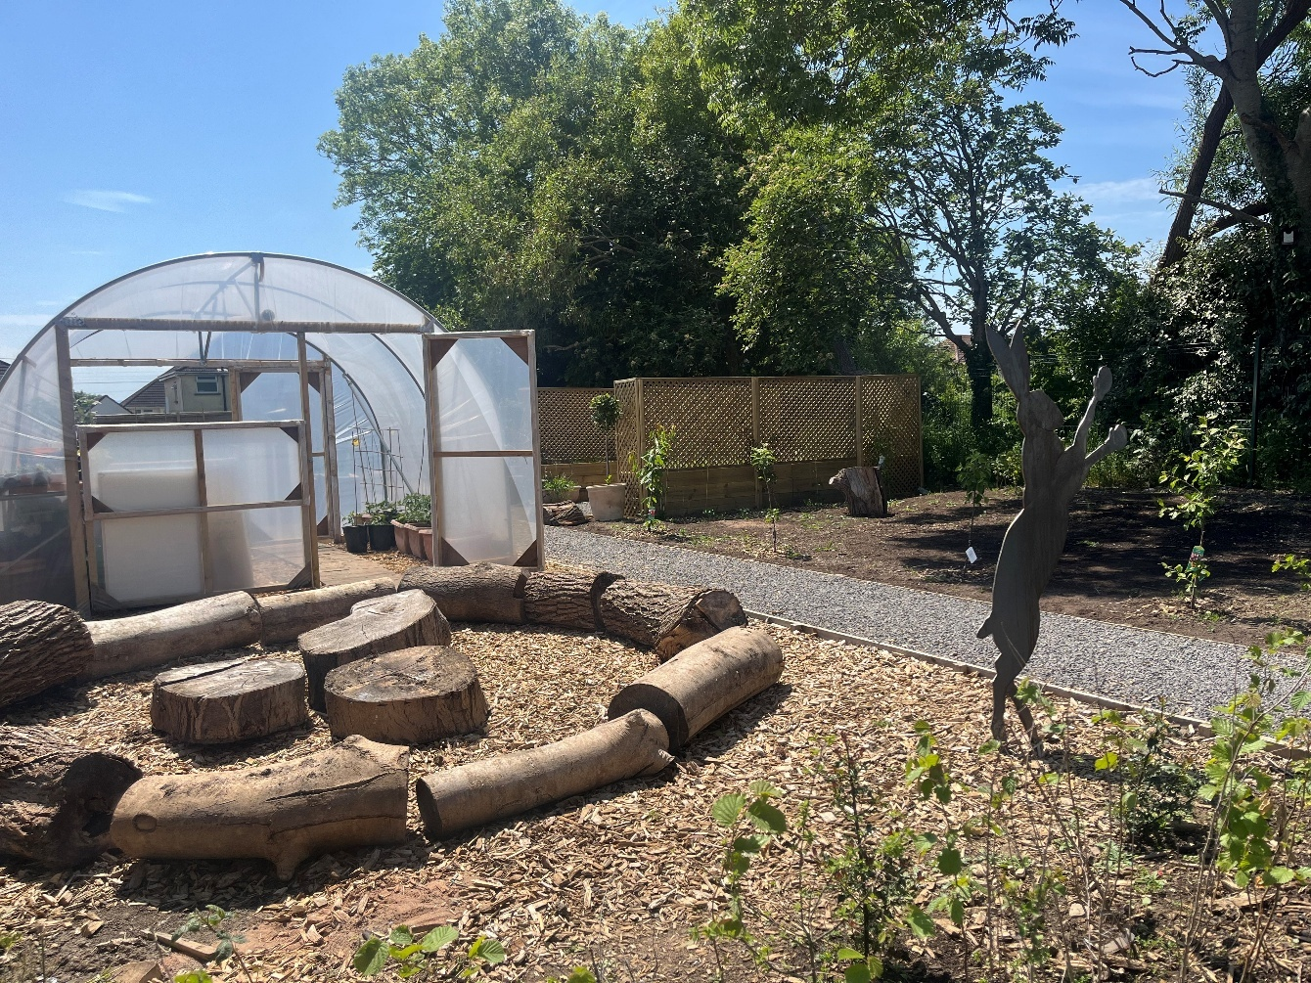

“IMPROVING THE WELL-BEING OF LLANTWIT MAJOR”
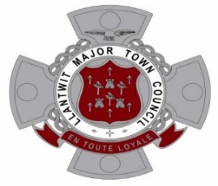

Contents Page
Contents | Page
Introduction from the Town Mayor | 3 - 5
Town Clerk report | 6
History of Llantwit Major Town Council | 7
Town Councillors | 8 - 13
Staff Team | 14 - 18
Town Council Committees | 19
Meeting Calendar | 20
Training Plan 2022 to 2027 | 21 - 26
Town Council Assets | 27 - 28
Finance 2025/26 | 29
Annual Audit Report 2024/25 | 30 - 37
Achievement 2025/26 | 38 - 39
Plans and Ongoing Projects 2026/27 | 40
A Prosperous Llantwit Major | 41 - 43
A Resilient Llantwit Major | 44 - 45
A Healthier Llantwit Major | 46 - 47
A More Equal Llantwit Major | 48 - 49
A Cohesive Llantwit Major | 50 - 51
Llantwit Major A Vibrant Culture and Thriving Welsh Language | 52 - 53
A Globally Responsible Llantwit Major | 54 - 55
Placemaking | 56 - 57
Project Pictures | 58 - 62
Contacts page | 63

Introduction from the Town Mayor, Councillor John Deakin
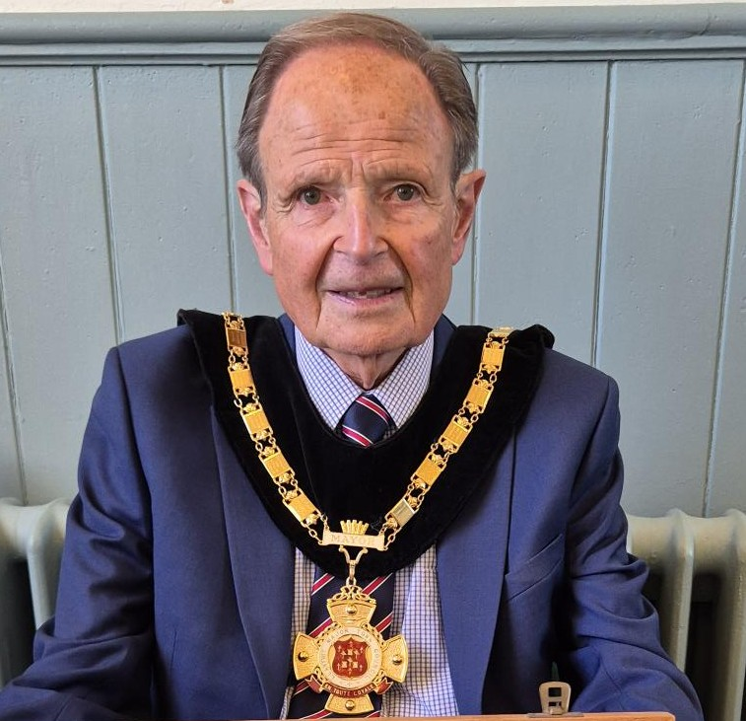
Throughout the last twelve months it has been my immense privilege and pleasure to serve as Town Mayor of our wonderful town. It was an honour that I did not expect, when I became a Town Councillor as recently as 2022. I will be forever grateful to our much-lamented colleague, the late David Foster for nominating me, First as Deputy Town Mayor two years ago, and then as Town Mayor last May. During my year of office supported by my Wife and consort Mary, I have endeavoured to carry out my duties to the best of my abilities and for the benefit of the whole town. I most certainly could not have done this without the support of my fellow councillors and the Town Hall Staff, who are superbly led by our excellent Town Clerk, Ruth Quinn.
My first duty as Town Mayor, only a couple of hours after my installation, was having the honour to read the tribute at the VE Day 80th Anniversary Ceremony at the Cenotaph. This was a particularly poignant moment for me as my late father served in France and Germany after D Day. As a Veteran myself, I particularly enjoy these types of events, and it was a real privilege to be back in the Town Square on Remembrance Day to lay a wreath on behalf of the Town Council. As is always the case on that day, there were many people along the parade route and at the Cenotaph to pay tribute to the fallen. It is particularly gratifying to see so many children and young people at the ceremony. Llantwit Major has always and continues to enjoy excellent relations with the military at MOD St Athan, and I was delighted to be invited to the Laying Up of the Colours of the 1st Battalion, The Parachute Regiment in St Illtud’s Church in July.
An integral part of the Town Mayor’s duties is to attend Civic Events in other towns and communities throughout the Vale of Glamorgan. We attended Civic Services in Cowbridge, Penarth, St Athan, Dinas Powys and Llandough. At all of these, it is a pleasure to meet and interact with civic leaders from the various town and villages. I have lost count of the number of events that we have attended in Barry, where we have become good friends with the Town Mayor, Councillor Dennis Clarke and his wife Janet.
A highlight of the year was our own Civic Service in St Illtud’s Church on Sunday 15th July, when we were honoured by the presence of numerous dignitaries from Cardiff and the Vale. Together with Councillors and guests, we paraded from the Town Hall to the church for an enjoyable service superbly conducted by Canon Edwin Counsel, which was sportingly themed given my background in football and running. Entertainment was provided by talented local violinist, Clarke Alonzi. Following the service there was a reception for guests held in the Llantonian Hall, which was bedecked in the colours of my beloved West Bromwich Albion, who I have supported since I was nine years old. A West Brom flag was also flown on the church tower.
As well as being a place of worship, St Illtud’s Church is much more, hosting many events and concerts and attracting visitors from far and wide to our town. Parts of it are not in the best state of repair, and it was with this in mind that I named the Church Restoration Fund my chosen charity for my Town Mayoral year, during which time we have held some successful fundraising events, the most popular of them being Rock and Roll Bingo.
We have been invited to a number of concerts during the past twelve months, all of which we have enjoyed immensely. There are certainly many talented musicians in and around Llantwit Major, who participated in a diverse range of concerts in the Annual Chamber Music Festivals, Early Voices Wales and the St. Donat’s Chorale. During December, we were also delighted to be invited to the Vale of Glamorgan Youth Orchestra Christmas Concert in the Hodinott Hall, which is situated in the Wales Millennium Centre. I have seldom heard classical music played to such a high standard. December was a particularly busy month, during which we were invited to Carol Services in Barry, firstly Nine Lessons and Carols in All Saints Church, followed by the Dementia Carol Service at the Baptist Church. It was also a great honour for me to be invited to read one of the Lessons at the Christmas Eve Service in our own St. Illtud’s Church.
Christmas is a very important time of the year for us all, particularly our children, and it is indeed always a pleasure to see their delight when Santa makes his Annual Sleigh Ride around Llantwit Major, when I am always happy to accompany the great man in my Elf’s costume. We are also very grateful to the excellent small group of volunteers who ensure that our Christmas lights are of the highest standard.
Earlier in the year during September, Llantwit Town Twinning Association welcomed a number of guests from Le Pouliguen in Brittany, who spent four days with us participating in an interesting programme, including a visit to Big Pit and a Food Festival at Margam Park. The Town Council welcomed our French friends at a Civic Reception in the Town Hall, which they all seemed to enjoy immensely. Whether they enjoyed or understood my speech delivered in French is highly debatable. A group from Llantwit Major, including the new Town Mayor, will be going on a Reciprocal Visit to Le Pouliguen in September 2026.
Llantwit Major is a vibrant town, where there are diverse ways of spending Leisure time. I am personally very interested in health and fitness, and there are sports clubs available to all ages. We have excellent Rugby and Football Clubs, who generally enjoy great success in their various competitions, while the facilities at our thriving Tennis and Bowls Clubs are very well utilised. I personally am a regular runner with the Llantwit Major Milers, whose members organise the popular Annual 10k Race, which is generously supported by the Town Council and local businesses. There is also a Nordic Walking Group and the Vale of Glamorgan Ramblers whose 50th Anniversary Event I attended in September.
We are also fortunate to have some excellent groups of volunteers, who make a valued contribution to our wellbeing. There are a large group of litter pickers who can be regularly seen throughout the town and surrounding area, While the award winning LLaniltud Fawr in Flower Group do a wonderful job planting and maintaining the flower beds in the town centre. There is also a similar group of volunteers who do similar work at the CF61 Building. The Town Council are also very grateful to the volunteers from schools and the community, who helped at the Stradling Park Community Garden, which was started from scratch on a derelict site and was so successful that it was nominated for an award by Open Spaces Wales. We were invited to the Awards Ceremony in Llandudno in Early October and while we didn’t win it was an honour to be there and witness the excellent projects being undertaken by volunteers throughout Wales.
Stradling Park was only one of the successful projects and initiatives undertaken during the past year. Placemaking has been very beneficial to the town, with improvements made at the Bowls and Tennis Clubs and the ongoing project to install a much needed lift in our Town Hall. As part of Placemaking in conjunction with the Vale of Glamorgan Council we recently held a week long Town Boost Project, which resulted in improvements to the Boverton Road toilets and a seated Leisure Area being constructed adjacent to to the Bakehouse Cafe. It was indeed very gratifying to witness the efforts of the significant volunteers who turned out to help with the project and hear the positive feedback from our citizens. Another notable achievement by the Town Council was acquiring the Transfer of the Public Toilets and Car Parks from the Vale of Glamorgan Council, ensuring that the facilities will be available to local people and visitors alike.
Attracting visitors is very important to our town, and if I see people who are obviously visiting, I have made a point throughout the past year of approaching them, introducing myself and welcoming them to Llantwit Major. I have met some interesting people from various countries, including Australia, the United States and several Europeans. Speaking of visitors reminds me that I have endeavoured to foster closer relations between Llantwit Major and Atlantic College. Last year the College celebrated 100 years since William Randolph Hearst purchased St Donat’s Castle and I was fortunate enough to be invited to the event staged to celebrate that Anniversary. I spoke to the Chair of the Governors and staff at that time, and we were all in agreement that we should work to re-establish relations that were somewhat paused by Covid. Since then, a significant number of students came to Purlon Farm to assist with a Tree Planting Day, when along with other volunteers they helped to plant in excess of 2500 saplings. I have since had a meeting with another group of students at the college who are keen to become more involved in the local community. I am always impressed by these wonderful young people who come from all parts of the world and appear to get on so well together. Others should certainly follow their example.

It is a great privilege to be a member of Llantwit Major Town Council, and I along with all my colleagues and staff endeavour to do our best for all the citizens of our wonderful town. Given our limited powers, it can at times be somewhat frustrating, but we will continue to do our upmost to improve the lives of all those young and old. I have enjoyed the total support of my fellow councillors throughout my year as Town Mayor, for which I will be eternally grateful. I must mention specifically Councillor David Foster, who passed away suddenly at the end of March. He was a great friend to us all and did so much for this town over many years; he leaves a void that will be very difficult to fill.
I look forward to handing over my Chain office to the new Town Mayor in May and wish him a happy and successful year.

Cllr John Deakin
Town Mayor

Town Clerk Report

This report was compiled following the introduction of the Well-being of Future Generations (Wales) Act 2015 and Local Government and Elections (Wales) Act 2021, Section 52.

The report shows how the Town Council has taken steps towards meeting local objectives as laid out in the local Well-being plan for our area. These objectives are based on our own knowledge and consideration of circumstances and characteristics for our area.

The Town Council has worked with many local organisations to meet the objectives laid out, either financially, administrative support or use of facilities.

Majority of ‘projects’ are now either on the Town Council website or social media sites. Feedback is always encouraged from local residents.

The report covers the municipal year of Councillor John Deakin’s term in office as Town Mayor and Chair of the Council, which started in May 2025.

The Town Council faced a challenging time with the financial restraints caused by the cost of living, but we have been fortunate to secure over £146,000 in funding from the National Lottery Grant, Shared Prosperity Fund, Transforming Towns - Placemaking Grant and All Wales Play Opportunities Capital Funding enabling us to deliver four projects to improve our Town for its residents, with two projects being completed during this municipal year and two being carried into the forthcoming year.

Unfortunately, with the lack of funding available for us to apply for in relation to events and with the large overhead costs to close roads, several events were unable to go ahead. We were, thankfully, able to support local groups and organisations, with small grant monies and administrative assistance so they were able to deliver several events in the Town.

The Town Council Sleigh made its rounds again this year, much to the delight of the local children, and adults.

Negotiations are still ongoing with the Vale of Glamorgan Council re transfer of assets for the Public Toilets and Car Parks in the Town Centre. There is still an issue to resolve regarding this potential asset transfer of one toilet block, but we are hopeful that the other assets should be transferred in the next couple of months. Unfortunately, due to the delay this resulted in a large underspend within our budget, but once it became apparent there would be delay, we ensured monies were ring-fenced, spent or allocated to other projects/services.

We were especially delighted that after all our hard work in assisting the Vale of Glamorgan Placemaking Team and Studiomyco Consultancy in undertaking and adopting a Placemaking Plan for the Town, we were able to secure funding for two projects, both of which will have a big impact on services we provide for residents.

I am extremely proud and grateful to lead our small team of five staff, who work incredibly hard, with the support of our Town Councillors, to ensure that the Council’s 27plus facilities and services continue to be delivered and maintained to the highest possible standard.

Ruth Quinn
(Town Clerk to Llantwit Major Town Council)
History of Llantwit Major Town Council

Llantwit Major Town Council serves a population of approximately 14,500. It is the third largest Town/Community Council within the catchment of the Vale of Glamorgan Council and is still growing with the new housing developments being built around our surrounding area.

The Town Council was formed in 1974 although before this Llantwit Major was served by a Parish Council and this can be traced back to 1894. The first Town Council Mayor was Mr A C W Davies (1974-75).

Llantwit Major (Llanilltud Fawr) is steeped in history with it being named as the site of the main church of Illtud, one of the founding Saints of the monastic settlements of the 5th century AD in Wales. Nowadays Llantwit Major is surrounded by countryside and has excellent transport links, as well as to the South the Bristol Channel and the Heritage Coastline.

Llantwit Major Town Council is made up of 13 elected Councillors and 1 co-opted Councillor representing 4 wards, West Ward, South East Ward, North Ward and Boverton Ward. There at present is a team of five staff working both full time and part time delivering services daily.

The Council is responsible for many facilities, including 5 community buildings (2 of which are listed), bowling green, tennis courts, 3 playparks, 4 open spaces, recreation field, ornamental pond, community garden, cemetery and allotment site.

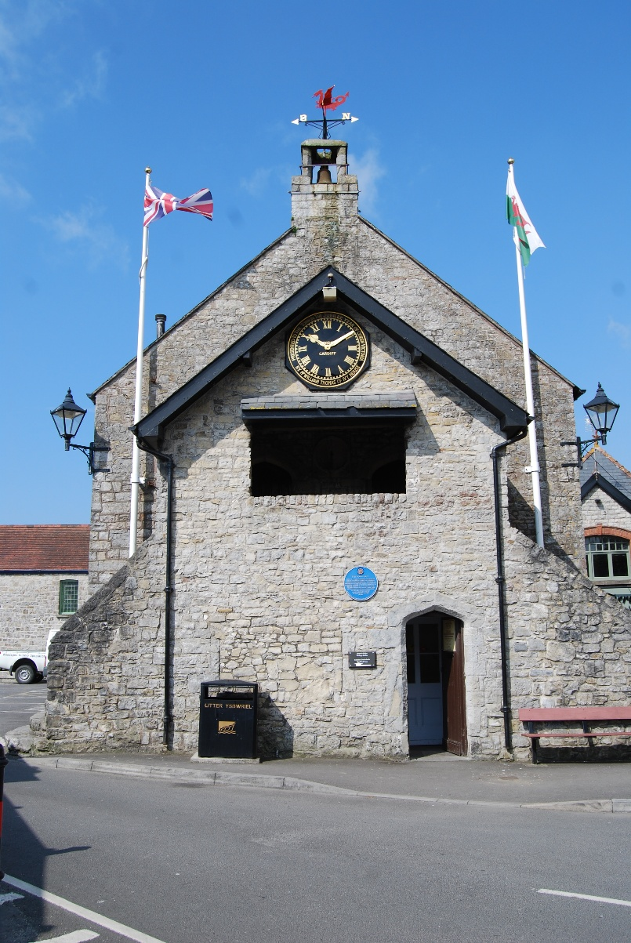

Town Councillors
West Ward
 | Cllr.DPowell@llantwitmajortowncouncil.gov.uk
Councillor David Powell  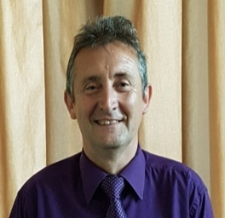 | Finance and Policy Committee  Recreation and Buildings Committee (Chair)  Footpath Forum (Chair)  Planning Committee (Deputy Chair)  Town Hall Working Group  5 Year Plan Committee  Allotment Sub Committee  Bowls Club Sub Committee  Tennis Club Sub Committee  Stradling Park Committee (Chair)
Why I became a Councillor?  What have I achieved? | The reason that I wanted to become a Town Councillor is that I have seen many changes in Llantwit Major in my lifetime and I was keen to ensure that Llantwit Major remained a place where people enjoy living and working. I have always been immensely proud of our historic town and local rural area. I felt that the town needed to be preserved and maintained for future generations and as a councillor something I could help to achieve. Being involved on the footpath committee ensuring our rural rights of way are maintained and, on the planning committee working to keep a balance between maintaining the character town, its rural surroundings and its growth have help to ensure that some of this has been achieved. Being elected Mayor has been an immense honour for me and given me the opportunity to invest my time on the council in helping the Town and its future.

 | Cllr.LHallan@llantwitmajortowncouncil.gov.uk
Councillor Dr Lesley Hallan  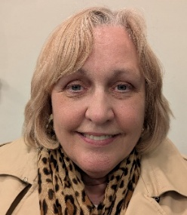 | Finance and Policy Committee  Recreation & Buildings Committee  Allotment Sub Committee (Chair)  Stradling Park Committee
Why I became a Councillor? | I am grateful for the opportunity to serve the community that is Llantwit Major. A community that has been warm and welcoming to me and my family. Whilst I am not a Llantonian, I am Welsh and went to school locally. I am a retired GP having worked in England for my professional life and retired to the town 8 years ago. We are fortunate to live in a place with such natural beauty, history and a vibrant social scene. There is always room for improvement, and I look forward to working with individuals, groups and interested parties to enhance the town for the benefit of everyone.

South East Ward
 | Cllr.JLewis@llantwitmajortowncouncil.gov.uk
Councillor John Lewis   | Finance and Policy Committee  Recreation and Buildings Committee
Why I became a Councillor?  What have I achieved? | I have lived in and around Llantwit Major for over 40 years. In that time, I was involved with youth football and the annual 10k race, both of which helped peripherally by the Town Council. It seemed like the right thing to do to stand for election and put something back into the community.

 | Cllr.GThomas@llantwitmajortowncouncil.gov.uk
Councillor Gerwyn Thomas  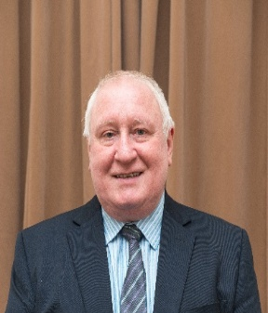 | Finance and Policy Committee  Recreation and Buildings Committee  Footpath Forum  Planning Committee  Town Hall Working Group  5 Year Plan Committee  Remembrance Day Committee  Vale of Glamorgan Community Liaison Committee  Pubwatch  Christmas Light Committee  Ysgol Dewi Sant Infant School (Governor)
Why I became a Councillor?  What have I achieved? | The reason I became a councillor was to give a little back to the town following my retirement in 2016.  My aspirations are not personal but are guided by what is necessary for the betterment of Llantwit Major.  My achievements, also, are not individual ones, but in being an active part of an effective team, working on behalf of residents.

 | Cllr.GMorgan@llantwitmajortowncouncil.gov.uk
Councillor Graham Morgan  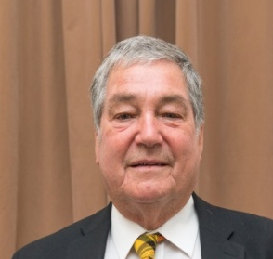 | Finance and Policy Committee  Recreation and Buildings Committee  Footpath Forum  Planning Committee  Town Hall Working Group  5 Year Plan Committee  Remembrance Day Committee  Stradling Park Committee  Bowls Club Sub Committee  Tennis Club Sub Committee
Why I became a Councillor?  What have I achieved? | During my tenure as Landlord of the Old White Hart, Llantwit Major 1st Independents held their monthly meetings there. I soon became aware of their policies and objectives with respect to their role in Llantwit Major and the Town Council in particular. I was particularly interested in the fact they were not influenced in any way by the policies of the mainstream political parties. To this end I offered myself as a potential candidate for the role Town Councillor South East Ward

Boverton Ward
 | Cllr.JDeakin@llantwitmajortowncouncil.gov.uk
Councillor John Deakin (Town Mayor)   | Finance and Policy Committee  Recreation and Buildings Committee  Planning Committee  Town Hall Working Group  Remembrance Day Committee  Stradling Park Committee  Town Twinning Association  Ysgol Ddraig Junior School (Governor)
Why I became a Councillor?  What have I achieved? | I have been fortunate enough to live in Llantwit Major since 1983 and have always found the majority of people to be both friendly and mutually supportive of one another. Since I retired, I have endeavoured to become more involved with Community Activities and saw seeking election to the Town Council as an opportunity to contribute to the well-being of people of all ages. We are exceedingly lucky to have access to the wonderful coast and countryside adjacent to our Town, and everything should be done to protect this legacy for future generations, which could be under threat from what I consider to be inappropriate development. I am also keen to see improvements in the town's infrastructure, particularly roads and pavements, which most people would consider to be in an unacceptable condition.

 | Cllr.SHanks@llantwitmajortowncouncil.gov.uk
Councillor Sally Hanks  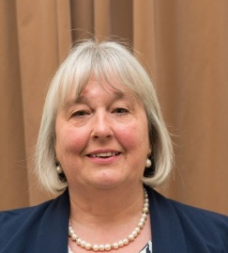 | Finance and Policy Committee  Recreation and Buildings Committee  Town Hall Working Group  5 Year Plan Committee
Why I became a Councillor?  What have I achieved? | Back in 2011 I personally became involved in a planning matter and was disgruntled with the way it was being handled. I spoke to Councillor Gwyn John who was a Town Councillor and a County Councillor, and after a few chats he suggested I stand as a Town Councillor. I was duly elected in May 2012 and have never looked back. I have always loved Llantwit Major and felt I had a good understanding and knowledge of the area. In 2016 I was elected as Mayor of Llantwit and was very proud and privileged to do so. I enjoyed being a Town Councillor so much that in 2017 I was elected to represent Llantwit as a County Councillor. I feel we have achieved much for Llantwit Major and Boverton over the years and aspire to achieve much more.

 | Cllr.WNorman@llantwitmajortowncouncil.gov.uk
Councillor William Norman   | Finance and Policy Committee  Recreation and Buildings Committee  Footpath Forum  Vale of Glamorgan Council Community Liaison Committee  Friends of Glamorgan Heritage Coast
Why I became a Councillor?  What have I achieved? | The reason I became a Councillor is, " as an old Llantonian family of six generations , I love our Town and wanted to give something back to it".  Furthermore, I have a great deal of knowledge on local history of the Town, experience in Safety and Civil Engineering and would like to use this to its best advantages for the betterment of our Town. It is a lot more work than I anticipated but I feel it is rewarding and worthwhile.  I am a practical person and have a common-sense approach to some of the issues we discuss. The more Senior Councillors have been very good with me and pass on constructive comments and feedback whilst I have been in this role. The Town hall staff are also excellent in providing support and direction whilst carrying out my duties. As for achievements, it is personally rewarding when you feel from your input that a positive result with the best direction for Llantwit Major is achieved.  Thank you all for your support thus far, I hope we all continue to work together to bring the very best for our historic and lovely Llantwit Major Town; to preserve and enhance it and give it the success it richly deserves in the Vale of Glamorgan

 | Cllr.GHughes@llantwitmajortowncouncil.gov.uk
Councillor Gill Hughes  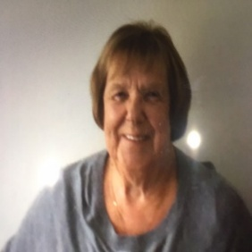 | Finance and Policy Committee  Recreation and Buildings Committee
Why I became a Councillor?  What have I achieved? | As soon as we moved into Llantwit Major I fell in love with the town.  The coastal position and friendly people made me want to contribute to the town in some way.  I brought experience of being on several committees both in my professional life as a pharmacist and in my social life I was heavily involved in bowls. I was the Secretary of Welsh Women’s Bowling association for 10 years.  I am involved with fund raising in St Illtud’s church and as a result have helped organise the Easter trail for the children and also the production of a calendar which raised considerable funds.

North Ward

 | Cllr.JNorman@llantwitmajortowncouncil.gov.uk
Councillor Jayne Norman  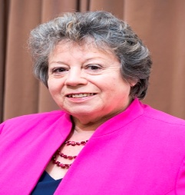 | Finance and Policy Committee  Recreation and Buildings Committee  Town Hall Working Group  Remembrance Day Committee  Llanilltyd Fawr in Flower
Why I became a Councillor?  What have I achieved? | I became a councillor as I felt that rather than complain that ‘Someone ought to do something about that!’, I should stand up and try and do something myself.  I feel that with the help of my fellow councillors we have managed to achieve many success within the Town, but on a personal level, I am proud to have been the Mayor of Llantwit Major (2017-18). I was instrumental in the introduction of the Period Poverty campaign in the County, ensuring that every girl in the Vale has access to hygiene products when needed. This is a topic I feel very strongly about and was delighted to see the Vale Council and the local schools embrace the idea and follow it through.
 | Cllr.PDickson@llantwitmajortowncouncil.gov.uk
Councillor Dr Peter Dickson  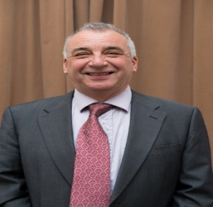 | Finance and Policy Committee  Recreation and Buildings Committee  Planning Committee (Chair)  5 Year Plan Committee  Allotment Sub Committee  Remembrance Day Committee  Stradling Park Committee  Friends of Glamorgan Heritage Coast  Public Service Board (VOGC)  Health and Social Care Committee  Placemaking Board
Why I became a Councillor?  What have I achieved? | I became a Councillor to try and use my life experience as both a GP and senior adviser in the Health Service to help the people of Llantwit Major, a town in which my wife and I are very pleased to be part of.  I have tried to listen to the concerns of residents and by working with the supportive Town Hall team, fellow Town Councillors and also Vale of Glamorgan Councillors, deal with issues to the best of my ability.  The past year has continued to be difficult because of the ongoing pandemic. However, I have contributed to Council meetings and sub-committees and also chaired the Planning sub-committee through 2021-22. This has involved establishing what I believe is a working relationship with the Vale Planning Officers so that they do attempt to listen to our concerns, even though our opinions may vary!  I hope that, given my background, I will be able to work towards improving the health and social care facilities for the people of Llantwit Major

 | Cllr.EWilliams@llantwitmajortowncouncil.gov.uk
Councillor Eddie Williams  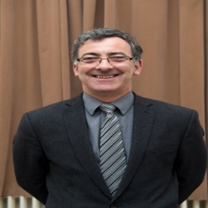 | Finance and Policy Committee  Recreation and Buildings Committee
Why I became a Councillor?  What have I achieved? | I wanted to contribute to the Town in which I’ve settled and brought up my family. I’ve seen many changes and want to continue to shape how it develops for the future. Since 2008, I’ve continued to serve the Town and surrounding area, taking into consideration all range of views and perspectives to bring about a safe and great place to live.

 | Cllr.DEllis@llantwitmajortowncouncil.gov.uk
Councillor Dr P David Ellis   | Finance and Policy Committee  Recreation and Buildings Committee  Town Hall Working Group
Why I became a Councillor?  What have I achieved? | I became a Town Councillor because I wished to play a role in promoting and developing Llantwit Major as an ideal place to live, especially with its unique history, coastal location and wide range of organisations and facilities, My vision is that of a caring and friendly community in which people feel safe and enjoy a good quality of life, whatever their age. Over the last five years I have succeeded particularly in establishing improved provision and facilities for older people and those with disabilities, creating a greener and more sustainable environment, reducing food poverty, and promoting Llantwit Major as a Fairtrade town. I am actively involved in campaigning for a new Health Centre.

 | Cllr.DFoster@llantwitmajortowncouncil.gov.uk
Councillor David Foster  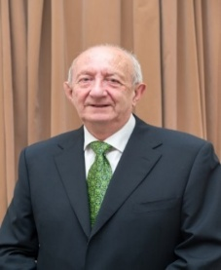 | Finance and Policy Committee (Chair)  Recreation and Buildings Committee  Planning Committee  Town Hall Working Group (Chair)  5 Year Plan Committee (Chair)  Allotment Sub Committee  Bowls Club Sub Committee  Tennis Club Sub Committee  St Illtyds Primary School (Governor)
Why I became a Councillor?  What have I achieved? | After working in local government for over 30 years I thought my experience might be of help.  The success of the Town Council is down to the Town Clerk and her staff. I hope I have been able to make a contribution to the work of the Council and provide a link between the staff and the Council.

Staff Team
Ruth Quinn – Town Clerk/Responsible Financial Officer
Based at the Town Council offices, Town Hall, works 37 hours a week.
Job Purpose:
- Undertake the duties of the Proper Officer and Responsible Financial Officer of Llantwit Major Town Council and act in accordance with the statutory duty to carry out all the functions, and to serve or issue all notifications required by law of a local authority’s Proper Officer.
- Take full responsibility for ensuring that the instructions of the Town Council in connection with its function as a Local Authority are carried out.
- Advise the Town Council on Standing Orders and policies to be followed, in respect of the Authority’s activities and to produce all the information required for making effective decisions
- Be accountable to Llantwit Major Town Council, for effective management of all its resources.
- To ensure an effective organisational structure is developed and implemented to meet the needs of the town council whilst balancing the need for financial efficiencies.
- Overall responsibility for all the financial records of the Council and administration of its finances
- Overall responsibility for ensuring compliance with current Health and Safety regulations.
- Overall responsibility for Cemetery Management and ensuring the council meets the statutory requirements for the safe custody of all documents, deeds, records and burial registers.

General Duties
- Develop proposals for the long-term strategic vision for Llantwit Major, considering developments in local government policy.
- Prepare, in consultation with appropriate members, agendas for meetings of the Town Council and its committees, attend such meetings and prepare minutes for approval.
- Manage, monitor and control town council facilities, service agreements and any partnerships entered into by them.
- Act as Council’s lead officer for future major projects
- Liaise and represent the council with the public, other public bodies and organisations including attending meetings with key stakeholders and positively promoting the council within the local community.
- Identify relevant sector-related information and distribute to Councillors.
- Receive and deal appropriately with correspondence and documents on behalf of the Council.
- Study reports and other data on matters relating to the business of the Council and discuss matters with specialists where required.
- Draw up, both on their own initiative and as a result of suggestions by Councillors, proposals for consideration by the Council and advise on feasibility, practicability and likely impact/effects of specific courses of action.
- Prepare, in consultation with the Chairman, press releases about the activities of or decisions of the Council.
- Attend relevant training courses to maintain continuous professional development.
- Act as a representative of the Town Council at meetings as required.

People Management
- Have overall responsibility for the work of LMTC staff ensuring that all requirements of employment legislation are adhered to and to be responsible for all aspects of the management and employment of staff.
- Undertake direct line management of specified staff members in keeping with the policies of the Town Council
- Undertake all necessary activities in connection with the management of salaries and conditions of employment.

Financial / Physical Resources
- Act as Responsible Financial Officer for the Council in respect of expenditure, income and fixed assets
- Overall responsibility for the preparation of the annual budget including precept, and the submission of annual accounts in accordance with financial regulations.
- Have delegated responsibility for expenditure in emergency situations up to a designated amount.
- Take responsibility for annual monitoring and balancing of the Council’s accounts and preparation of records for audit purposes and VAT and ensuring these provide value for money.

Policy
- Ensure that legal, statutory and other provisions governing or affecting the running of the Council are observed and ensure that Council members have an up to date understanding of their statutory and other responsibilities.

Dawn Howles – Deputy Town Clerk (May to August)
Rhian Bostanci – Deputy Town Clerk (July to May)

Based at the Town Council offices, Town Hall, works 30 hours a week.
The Deputy Town Clerk will deputise for the Town Clerk and carry out the statutory and delegated functions of the Town Clerk in his/her absence due to annual leave or sickness.
- Ensure that statutory and other provisions governing or affecting the running of the Council are observed.
- Support the Town Clerk in ensuring that the Council’s obligations for Health and Safety Regulations are properly met.
- Prepare, in consultation with members, agendas for meetings of the Council and Committees. To attend such meetings and prepare minutes for approval, other than where such duties have been delegated to another Officer.
- In the absence of the Town Clerk cover their absence at the office, work with the Chairmen of other Committees to establish agendas, attend and subsequently minute Council and committee meetings
- Have responsibility for supporting the work of the Planning Committee
- Support the Clerk in the delivery of assets to the Town Council
- Support the Clerk in maintaining and monitoring all systems and records relating to the Council’s management of assets, including buildings, public open spaces and public realm
- Act as the officer responsible for collating requests for allotments and leading on the introduction and development of allotment provision (including tenant liaison)
- Act as the officer responsible for developing and updating the website with Council information, agendas, minutes and news items
- Support the Clerk in the procurement of goods and services for the Council
- Support the Clerk to ensure the timely and effective management of the Council’s ongoing supply contracts renewals
- Identify funding sources to support the on-going work of the Town Council, including community development work, as appropriate and to prepare funding applications for submission
- Receive correspondence and documents on behalf of the Council and to deal with the correspondence or documents or bring such items to the attention of the Council. To issue correspondence as a result of instructions or the known policy of the Council
- Study reports and other data on activities of the Council and on matters bearing on those activities. Where appropriate, to discuss such matters with administrators and specialists in particular fields and to produce reports for circulation and discussion by the Council.
- Draw up on his/her own initiative and as a result of suggestions by Councillors, proposals for consideration by the Council and to advise on the practicability and likely effects of specific courses of action
- In the absence of the Clerk to supervise staff members and manage the day-to-day running of the Council offices
- Act as the representative of the Council where required
- Prepare in consultation with the Chairman and other Councillors as appropriate, press releases about the activities or decisions of the Council
- Prepare newsletters, posters and advertisements pertaining to Council business
- Assist in the organisation of Town Council events
- Attend training courses or seminars on the work and role of the Clerk and Council as required 26. Participate in the annual appraisal scheme.
- Continue to acquire the necessary professional knowledge require for the efficient management of the affairs of the Council; membership of The Society of Local Council Clerks is suggested
- Undertake any other reasonable tasks as directed by the Town Clerk
Mr Raymond Duncan – Gardener/Handyman
Based at the Recreation Ground, works 37 hours a week.
To maintain high standards of maintenance of Council assets within the town.
Main duties/responsibilities
- Mowing and strimming of two parks and an Allotment site.
- General maintenance in Parks, including benches & play equipment.
- To provide flower displays at various points around the town, including around the Cenotaph and the Town Hall Building
- General maintenance and upkeep of all Town Council Buildings
- Internal decorating (painting).
- External cleaning and tidying/weeding, litter picking around Council buildings car parks, parks, cemetery, West Streel Pond and allotment site.
- Awareness and implementation of health and safety responsibilities as an employee.
- Fulfil necessary administrative tasks associated with the responsibilities of the post
- e.g., Time sheets, maintenance fault log reporting, consumables ordering, Legionnaire testing.
- Being courteous and friendly to members of the public as the ‘face’ of the Town Council.
- Take a flexible approach in order to meet the Council’s requirements.
- To maintain/ upkeep of tools / ride on mower / town council van to undertake the role.
- Undertake other duties that may be required from time to time within the general scope of the post.

Mrs Janine Flanigan – Administrative Assistant (May to April)
Based at the Town Council offices, Town Hall, works 30 hours a week.
- To provide administrative support to the Town Clerk and Deputy Town Clerk (as listed on attachment)
- To assist in the process of developing service delivery and improvement plans for the Council’s services and activities
- To administer all paperwork associated with the Footpath Forum, including the preparation of agendas, reports and to act as appropriate as a result of such meetings
- To maintain the Town Mayors Diary and liaise directly with the Town Mayor regarding functions and duties.
- Oversee the booking diaries for all Council owned premises.
- To cover front office
- Attend and support evening and weekend events as required
- Such other duties and responsibilities commensurate with the grade and in accordance with the general character of the job as may reasonably be required by the Town Council from time to time
- Undertake the development/administration of the Stradling Park Community Garden

Mrs L Heffernan – Cleaner/caretaker, Town Hall
Based at Town Hall & Old School, works 16 hours a week.
Duties include;
- To follow timetable for cleaning up to 4 council buildings dependent upon usage and requirements.
- Responsibilities to include Cleaning, washing, sweeping, vacuum cleaning, emptying of litter bins, polishing and dusting including toilets, and washbasins, and fixture and fittings, using where appropriate powered equipment, and cleaning materials. Clean windows/glass surfaces. Clean light fittings/shades
- Ensuring that washroom facilities/toilet areas are regularly inspected to maintain a high standard of cleanliness and that they are maintained with an adequate supply of soap, toilet rolls etc
- Ensuring sufficient stocks of essential janitorial materials are maintained e.g., soap, paper towels, toilet rolls, light bulbs etc
- Convey waste produce to the appropriate central refuse area as required. undertake the sorting of rubbish in compliance with the town council’s recycling policy.
- Undertake internal and external training as specified by the Town Clerk or the Council
- Any other duties as reasonable requested by the Clerk or Council

Town Council Committees
(as elected at the Annual meeting 8th May 2025)

FINANCE AND POLICY COMMITTEE
RECREATION & BUILDING COMMITTEE
FOOTPATH FORUM
PLANNING COMMITTEE
TOWN HALL WORKING GROUP
5 YEAR PLAN COMMITTEE
ALLOTMENT SUB COMMITTEE
BOWLS CLUB SUB COMMITTEE
TENNIS CLUB SUB COMMITTEE
REMEMBRANCE DAY COMMITTEE
STRADLING PARK COMMITTEE
APPEAL HEARING (PERSONNEL)
APPEALS COMMITTEE (PERSONNEL)
GRIEVANCE PANEL (PERSONNEL)
INTERVIEW PANEL

TOWN COUNCIL REPRESENTATIVES ON OUTSIDE BODIES/COMMITTEES
VALE OF GLAMORGAN COMMUNITY LIAISON COMMITTEE
LLANILLTYD FAWR IN FLOWER
PUBWATCH
FRIENDS OF GLAMORGAN HERITAGE COAST
LLANTWIT MAJOR CHAMBER OF TRADE
CHRISTMAS LIGHT COMMITTEE
TOWN TWINNING ASSOCIATION
HEALTH AND SOCIAL CARE COMMITTEE
PUBLIC SERVICE BOARD (VOGC)

MINOR AUTHORITY REPRESENTATION
ST. ILLTYD’S JUNIOR & INFANT SCHOOL
YSGOL DEWI SANT INFANT SCHOOL
YSGOL DDRAIG JUNIOR SCHOOL

Calendar of Town Council Meetings 2025/26

2025
29th MAY FULL TOWN COUNCIL MEETING
12th JUNE FINANCE AND POLICY COMMITTEE
26th JUNE FULL TOWN COUNCIL
7th JULY FOOTPATH FORUM
31st JULY FULL TOWN COUNCIL
25th SEPT FULL TOWN COUNCIL
6th OCT FOOTPATH FORUM
16th OCT FINANCE AND POLICY COMMITTEE
30th OCT FULL TOWN COUNCIL
27th NOV FULL TOWN COUNCIL
18th DEC FULL TOWN COUNCIL

2026
15th JAN FINANCE AND POLICY COMMITTEE
19th JAN FOOTPATH FORUM
29th JAN FULL TOWN COUNCIL
26th FEB FULL TOWN COUNCIL
26th MARCH FULL TOWN COUNCIL
13th APRIL FOOTPATH FORUM
30th APRIL FULL TOWN COUNCIL
14th MAY ANNUAL MEETING

OTHER COMMITTEE MEETINGS
PLANNING COMMITTEE DATES TO BE DECIDED WHEN REQUIRED
BUILDING AND RECREATIONS COMMITTEE DATES TO BE DECIDED WHEN REQUIRED
5 YEAR PLAN COMMITTEE DATES TO BE DECIDED WHEN REQUIRED
WORKING GROUP DATES TO BE DECIDED WHEN REQUIRED

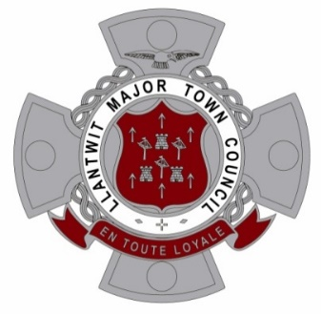
Llantwit Major Town Council
Training Plan 2022 – 2027

Reviewed and adopted 29th January 2026

Llantwit Major Town Council, as per section 67 of the Local Government and Elections (Wales) Act 2021, is obligated to formulate a plan addressing the training needs of councillors and employees.

This training plan aligns with guidance from the Society of Local Council Clerks. It prioritises resources to support all council roles through tailored training and development. The commitment outlined in this plan aims to enhance service delivery to the community. Regular reviews will ensure its relevance and adaptability to evolving needs and personnel changes.

The plan aims to equip councillors and employees collectively with the knowledge for effective council operation. Diverse training ensures varied expertise across the council.

After each ordinary election, a new plan reflecting changes in council membership will be drafted. While this is the inaugural plan, future iterations will ensure ongoing relevance.

For council employees, individual training needs are identified during annual performance reviews. A preliminary assessment of councillors' essential skills informs immediate training priorities.

The Town Clerk will provide guidance to new members during their initial 6 to 12 months in office. Further assessment of councillor training needs will occur later in the financial year.

Key areas of focus include Basic Induction for Councillors and Code of Conduct. Additionally, new challenges such as those posed by the General Power of Competence will be addressed.

This plan serves as a baseline, subject to periodic review and updates over the next year, leading up to the 2027 local government elections. Upon council approval, it will be published on the Town Council Website.

Reference should also be made the Llantwit Major Town Councils Training and Development Policy.

- OBJECTIVE
The Town Council consists of elected Councillors and employs members of staff. The Town Council firmly believes that to be successful in delivering services to the public is to be properly trained to carry out our respective roles. The Town Council is committed in supporting Councillors and Employees through its training and development programme.

- HOW DO WE IDENTIFY TRAINING NEEDS?
Through:
- Individual Training Programmes specific to the various roles (see employees’ training Programme) Identifying further personal training needs of employees through the Staff Review and Development Programme. A record of training will be kept centrally and in personnel files
- Councillor and Employee Induction programmes
- Assessment of Training needs of Committee members (see Councillors’ Training Programme)
- Regular review of new Government legislation and guidelines which will require training to meet changes
- The Town Clerk to follow the Continuing Professional Development programme recommended by the Society of Local Council Clerks
- Recommendations on Councillors training courses and conferences offered through the National Association of Local Councils

- HOW IS TRAINING FUNDED?
Each year prior to budget setting the Town Clerk and Councillors will complete a training needs analysis to identify training needs for the following financial year and make recommendations to the Council for budget required to fulfil the council’s commitment to training and development of its staff and councillors. Continuing Membership of SLCC will provide further opportunities for reduced training costs.

- OUR INVOLVEMENT IN THE TRAINING STATEMENT OF INTENT
Continued learning and development will ensure the Town Council remains an effective organisation. Officers and Councillors will be encouraged to think about the skills they need to do the job and make them known, staff will advise their line managers/ the Town Clerk. In addition, any essential training required for some post holders will be set out in an Employee Training Programme and or continuing professional development programme where appropriate.

- WHAT WE CAN EXPECT FROM THE TRAINING PROGRAMMES
- To receive an Employee or Councillor induction to the post
- To have an identified and accessible Line Manager
- To receive regular supervision
- To be made aware of appropriate training and development opportunities
- To be encouraged to consider and identify your own developmental needs considering any specified skills for our posts and through supervision and discussions
- To discuss Personal development during the review with your Line Manager/Supervisor
- To have a record of any development/training undertaken
- To have access to relevant learning materials and reference books at the Town Council
- To take responsibility ourselves to maintain and improve our knowledge and skills.

- TRAINING PROGRAMME FOR EMPLOYEES
Town Clerk Induction, to include H&S, Risk Assessments, Mental Health Awareness for Managers, Stress Awareness for Managers, IOSH Managing Safely, Staff Handbook, Council Policies, ILCA/CiLCA, Community Governance, SLCC CPD programme any relevant management training.
WHO | WHAT | HOW | WHEN | COMMENTARY | OUTCOME
All Councillors | Basic induction to the Town Council | Induction pack providing an overview. | Following election/co-option | A members information pack (see appendix A for list of documentation) is issued to all new Town Councillors to support them in the induction programme | All councillor issued packs
All Councillors | Basic induction to the Town Council | Introduction meeting | Prior to Annual meeting or first meeting of Town Council | Town Clerk to meet with new Councillor/s to discuss roles and responsibilities and answer any questions following the circulation of information pack | All councillors attended
All Councillors | Code of Conduct training | Remote training either from VOG Council or OVW | Within 6 months of being elected | All new Councillors are encouraged to attend this training | All councillors have undertaken the training expect LH due to no course available at time
All Councillors | Equality and Diversity training | In person by outside agency | By May 2025 | All Councillors are encouraged to attend this training | Half councillors attended training Jan 25
All Councillors | Planning from start to finish | Remote training from Planning Aid Wales | By Dec 2026 | All Councillors will be enrolled on the course when it becomes available. | Some councillors have completed course
All Councillors | Various courses designed for Councillors | Remote training from One Voice Wales | By Dec 2026 | All Councillors regularly circulated with training courses and dates of courses run by OVW
Chair & Deputy Chair of Planning Committee | Planning with Community, Making Your Voice Heard | Remote training from Planning Aid Wales | On appointment to post | Enrol on course which is available via Planning Aid Wales website | PD & DP completed course

WHO | WHAT | HOW | WHEN | COMMENTARY | OUTCOME
Town Clerk/RFO | Certificate in Local Council Administration (CiLCA) | Formal qualification | Within 2 years of appointment | The Town Clerk already holds this qualification which evaluates whether you have a broad knowledge of all aspects of the Clerk’s work – roles & responsibilities, the law, procedures, finance, planning and community involvement | Completed
Town Clerk/RFO | Institute of Cemetery (ICCM) Management Course | Formal qualification | Within 2 years of appointment | The Town Clerk already holds this qualification - covers all aspect of managing cemetery’s | Completed
Town Clerk/RFO | Finance in Local Council Administration (FiLCA) | Formal Qualification | Within 2 years of appointment | Covers all aspect of finance and governance of the Council – New qualification | Dec 25  Completed
Town Clerk/RFO | Planning from start to finish | Remote training from Planning Aid Wales | By Dec 2026 | To gain an understanding of planning and how to produce observations to planning application – assist Town Councillors in discussing and producing comments to planning applications | Completed
Deputy Town Clerk | Introduction to Local Council Administration (ILCA) | Formal qualification | Within 2 years of appointment |  | Dec 27
Deputy Town Clerk | Certificate in Local Council Administration (CiLCA) | Formal qualification | Within 2 years of appointment |  | Dec 27
Deputy Town Clerk | Planning from start to finish | Remote training from Planning Aid Wales | Within 6 months of appointment | To gain an understanding of planning and how to produce observations to planning application – assist Town Councillors in discussing and producing comments to planning applications | Completed
Deputy Town Clerk | Equality and Diversity training | In person by outside agency | By May 2027 | All current staff have attended this training. DTC newly appointed after training
WHO | WHAT | HOW | WHEN | COMMENTARY | OUTCOME
Gardener/handyman | Provisions on use of equipment | Formal qualification | Within 2 years of appointment | Already completed | Completed
Gardener/handyman | Work equipment awareness | Formal qualification | Within 2 years of appointment | Already completed | Completed
Gardener/handyman | Basic tree survey & inspections | Formal Qualification | Within 2 years of appointment | Already completed | Completed
Gardener/handyman | Playground equipment safety | Formal qualification | By Dec 2023 | To gain an understanding to allow for competent completion of daily checksheets | Completed
All Town Council staff | First Aid | Formal training | End of Jan 25 | Essential course for staff to complete to become first aid trained | Completed
All Town Council staff | Manual handling | Formal qualification | By May 2027 | To be undertaken online with newly appointed H&S advisors (Coroner)
All Town Council staff | Various online training course as provided by Coroner including  - Asbestos awareness  - Fire safety  - Risk assessments  - COSHH Awareness  - Working at heights  - Slips, trip & falls  - Noise awareness  - Lone working  - Legionella | Formal training | Ongoing | Reviewed and discussed at annual staff appraisals.
ESTIMATED COSTS OF THE TRAINING IN EACH COUNCIL YEAR (To be included in the annual budget for each of the next five years):

Financial Year | Amount to be included in the budget at 2022 Prices (£) | Comments
2022/23 | £1,000 | Underspend £620
2023/24 | £1,000 | Underspend £460
2024/25 | £1,000 | Overspend £ 509
2025/26 | £1,000 | Underspend £702
2026/27 | £2,000

Town Council Assets
Recreation Ground
Boverton Road, Llantwit Major – 9.63 Acres
- Two play areas
- Exercise equipment
- Three rugby pitches
- Open space with seats and trees
- Tennis courts
- Bowling green
- Two sports pavilions
- Garage
- Bins

Seaview Park
Colhugh Street, Llantwit Major – 4.64 Acres
- Open green space
- Benches
- Bins

Lorna Hughes Park
High Street, Llantwit Major - 0.78 Acres
- Small wooded landscaped open space
- Benches
- Bins

Stradling Park
Off Stradling Place, Llantwit Major – 0.81 Acres
- Open green space
- Community garden
- Benches
- Bins

Cenotaph and Steps
Church Street, Llantwit Major
- War memorial Grade II listed
- Benches

West Street Pond
West End, Llantwit Major
- Ornamental Pond
- Grade II listed ancient Midwell
- Benches
- Bins
- Biodiversity enhanced site

Allotments
Llanmaes Road, Llantwit Major – 2.5 Acres
- 108 allotment plots

Cemetery
Boverton Road, Llantwit Major – 2.64 Acres
- Burial and cremation plots
- Stillbirth and children’s memorial garden
- Memorial benches

Old School
Wine Street, Llantwit Major – Grade II Listed Building
- Permanent facility for secondary and nursery schools
- Rooms to rent for educational use
- Archive room for local history group
- Council chamber
- Licenced wedding ceremonial venue

Town Hall
Church Street, Llantwit Major – Grade II* Listed Building
- Town Council offices
- Main hall for hire community and recreational events
- Public entertainment licenced
- Small meeting room
- Historic birdcage turret clock
- Small car parking

Llantonian Hall
Off Boverton Road, Llantwit Major – Community Building
- Hall for hire community and recreational events
- Public entertainment licenced

Finances 2025/26
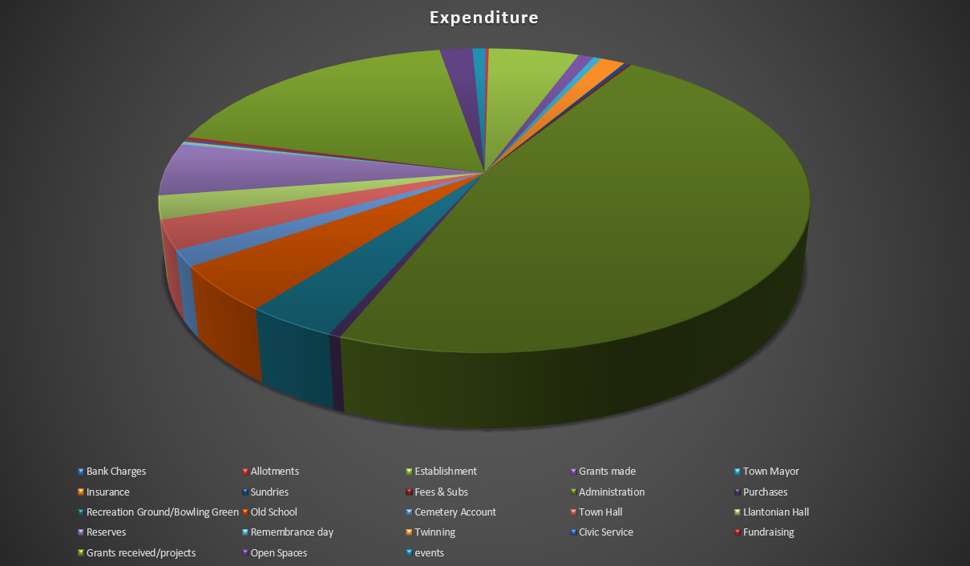
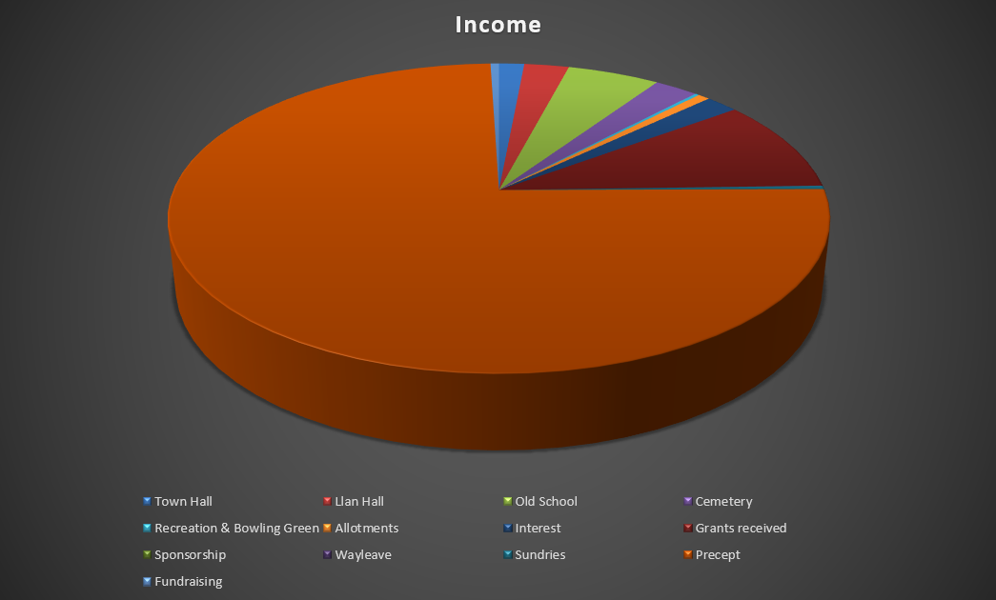

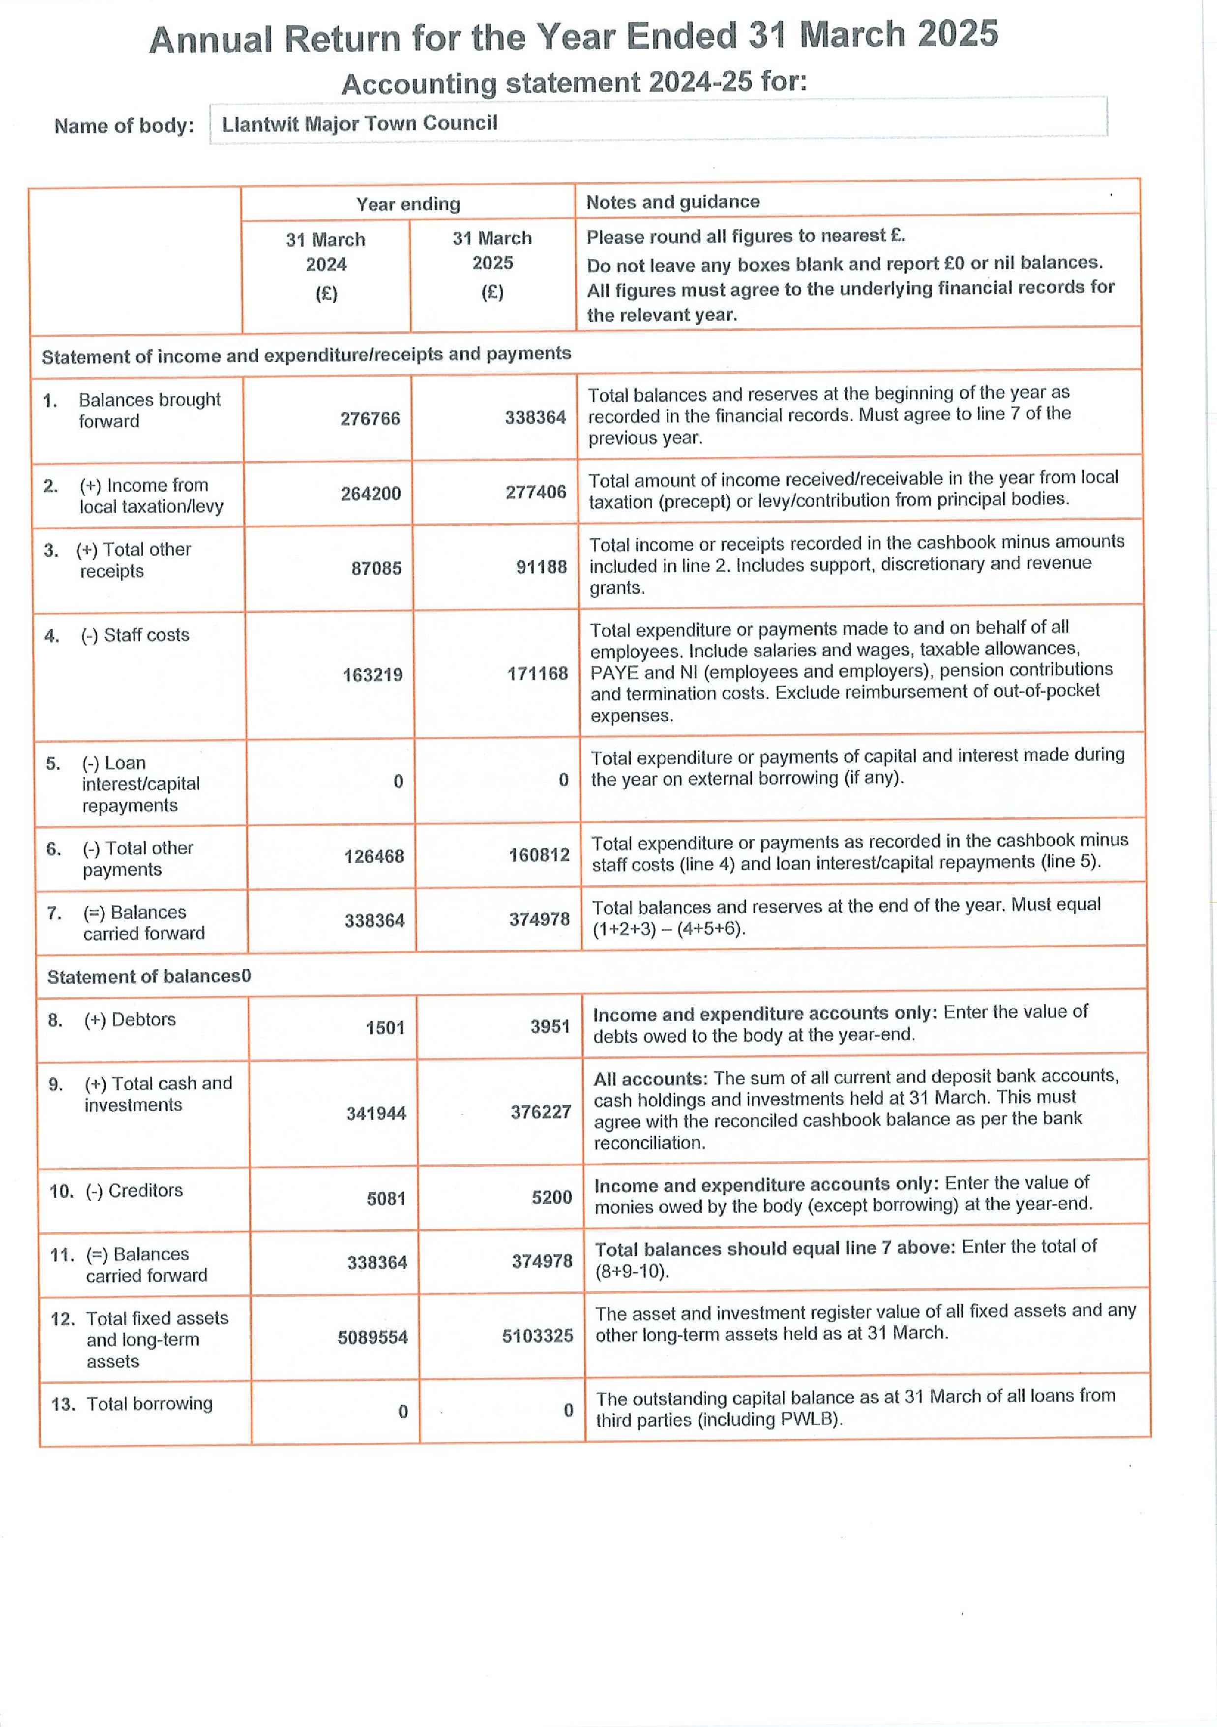
Annual Audit 2024/2025
(previous financial year)
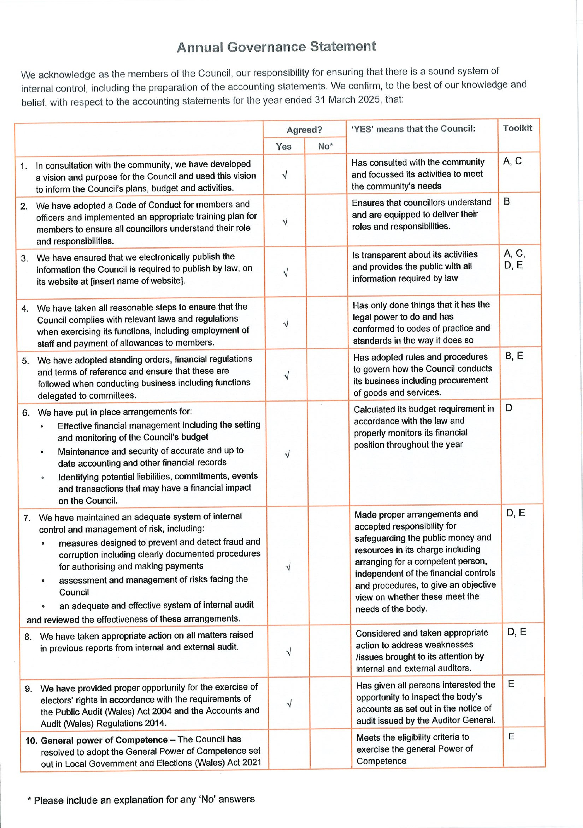
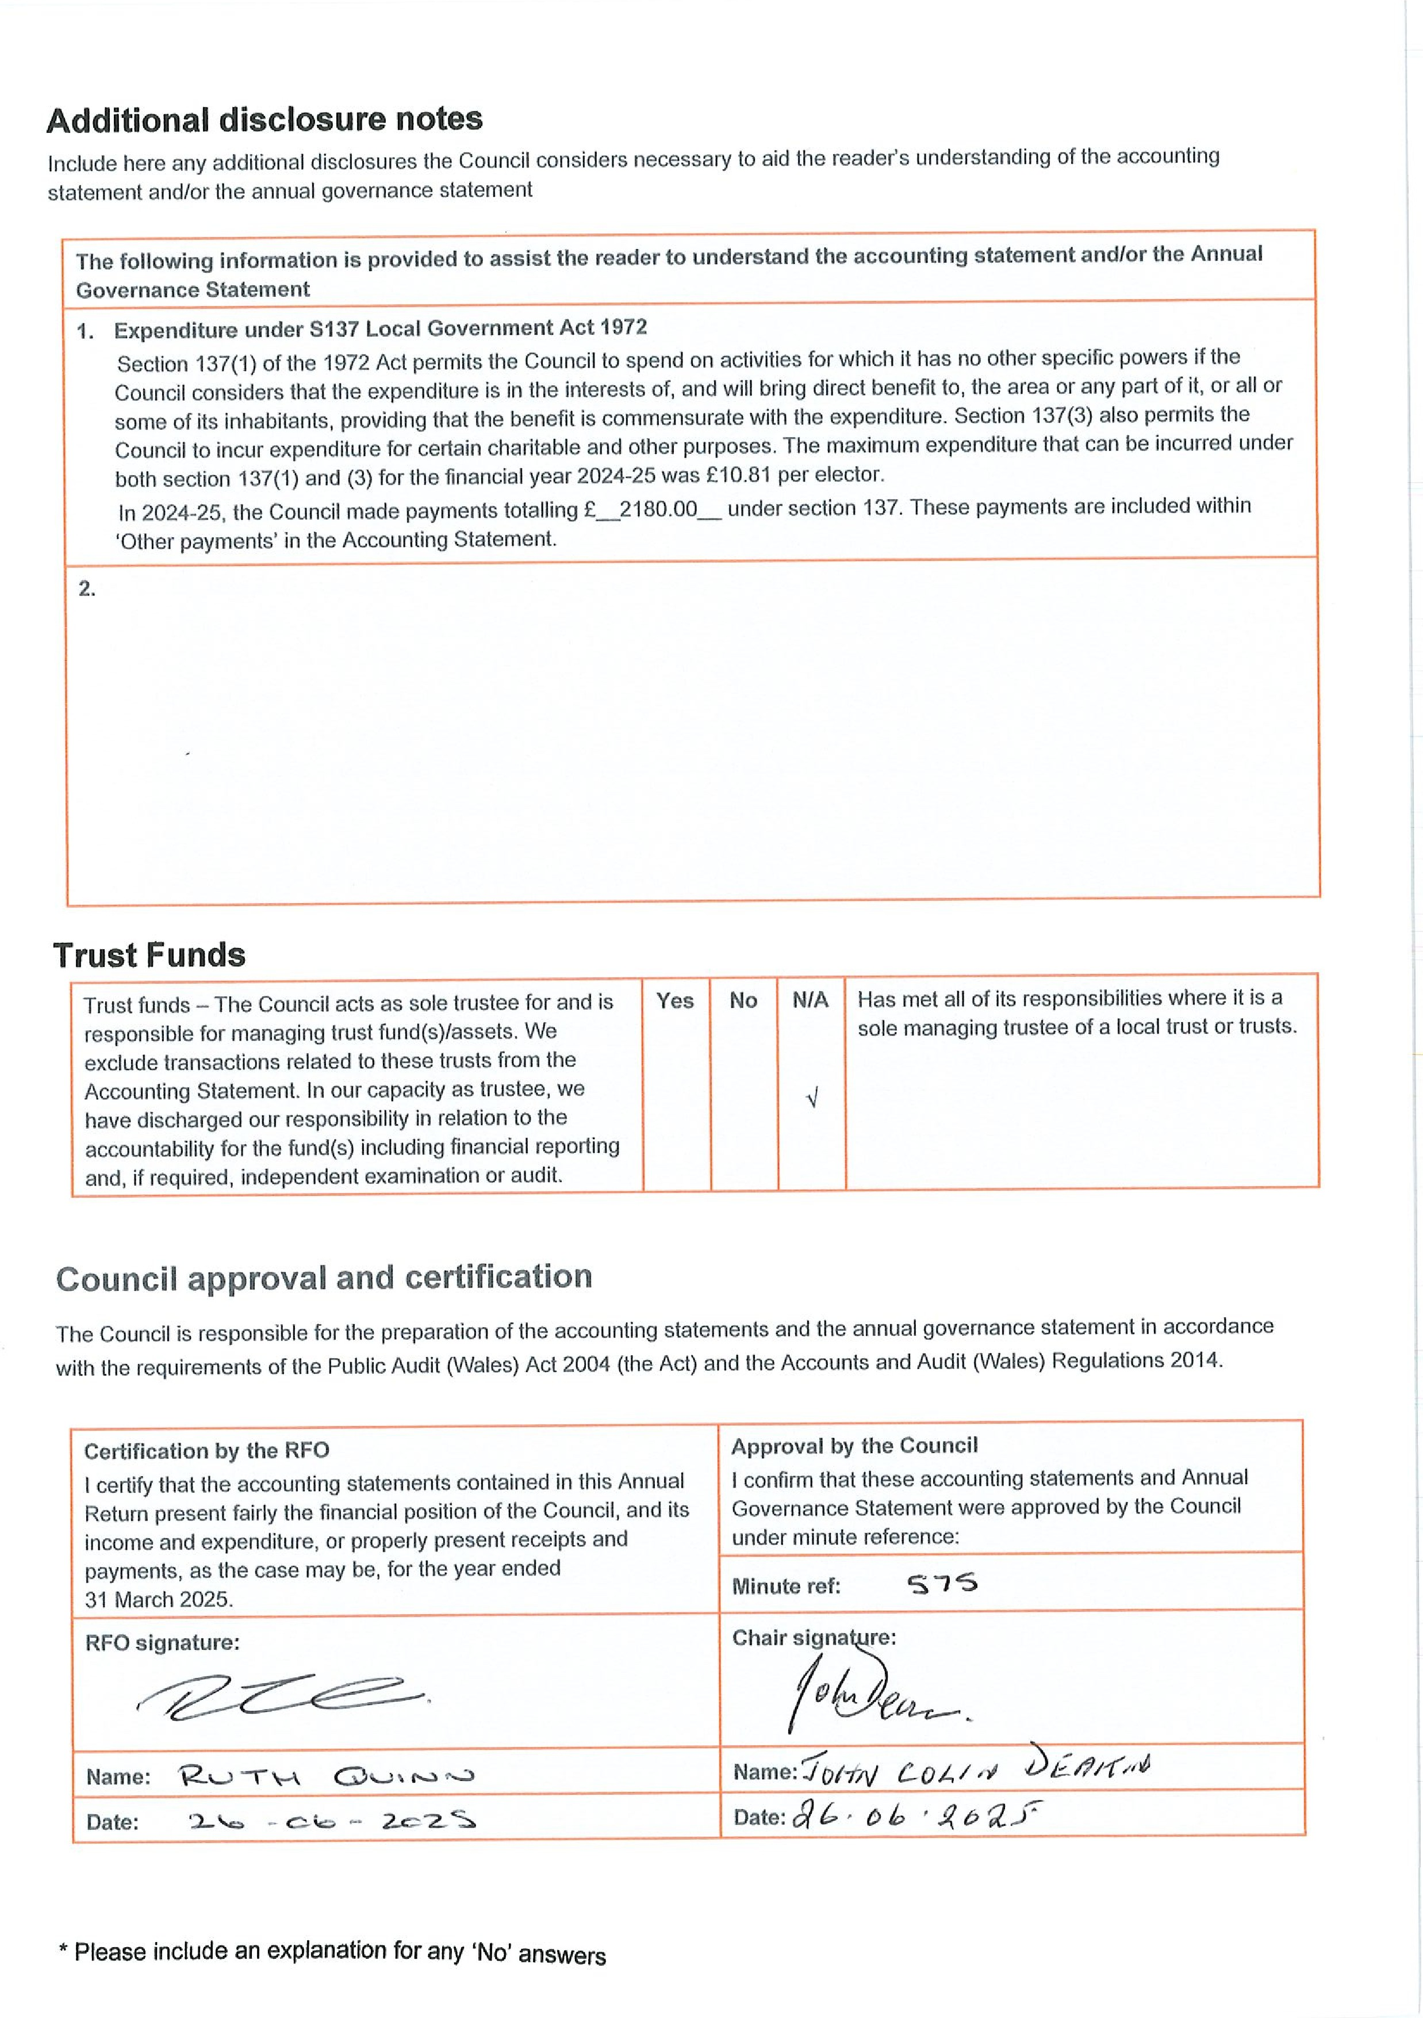
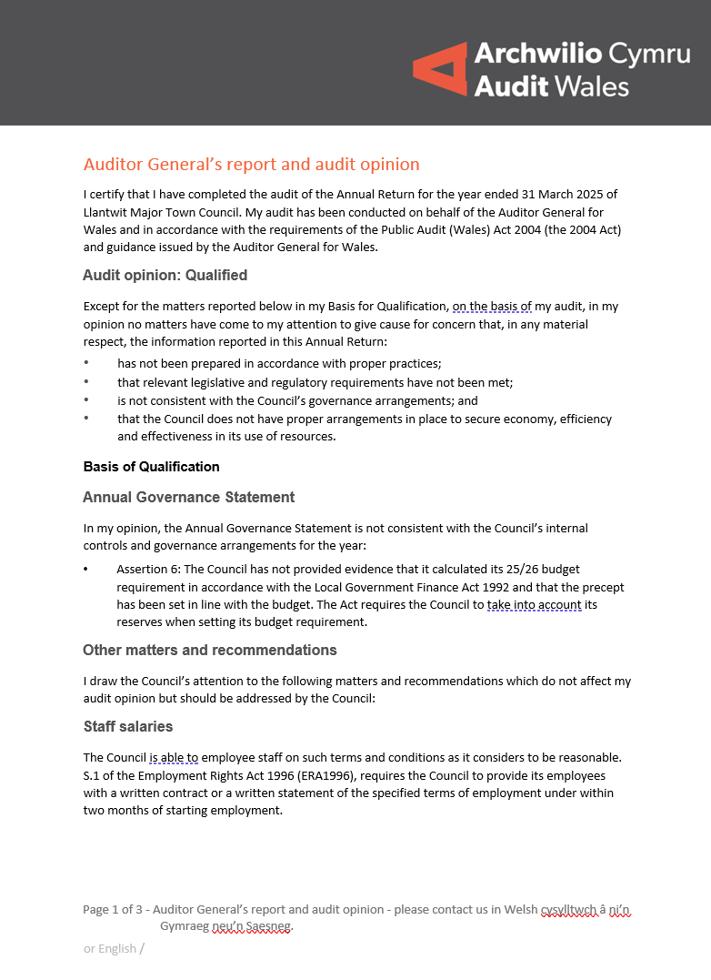
The Clerk’s contract specifies a fixed pay point but Council documents refer to the Clerk being paid on a ‘sliding scale’. This does not provide an adequate basis for pay. I have written to the Council separately regarding the Clerk’s pay.
Our audit work also identified inconsistencies in salaries paid to two other members of staff who appear to be paid below their contracted salary.
We would recommend that the Council reviews their staff contracts and ensure that staff are paid in accordance with contracts of employment.

Reserves
The Council has carried forward reserves of £374,978 compared to its annual precept of £277,406. The closing balances have been steadily increasing for a number of years.
The Local Government Finance Act 1992 only allows the Council to set a precept to fund planned expenditure and requires it to take its reserves into account when setting the precept. It is not clear from the information provided for audit whether or not the Council has taken its increasing reserves into account when setting the precept.
To ensure that it sets a lawful precept, we recommend that the Council reviews its reserves and its plans to apply these reserves when setting its future budgets and precept. Further guidance is found in the Practitioners’ Guide.

Training plan
The Local Government and Elections (Wales) Act 2021, requires the Council to create and publish a plan for councillor and staff training. The Welsh Government provides statutory guidance on this, which states that the plan must be approved by the full council and include details on the type of training, participant numbers, timeframe, and cost.
The training plan provided for audit does not contain the basic information required above.
We recommend that the Council reviews its Training Plan in line with the Welsh Government guidance.

General Power of Competence
The Council has not provided a response to assertion 10 in the Annual Governance Statement.
Page 2 of 3 - Auditor General’s report and audit opinion - Please contact us in Welsh Cysylltwch â ni’n Gymraeg neu’n Saesneg.

We recommend that before the Council complete the Annual Governance Statement, the Council carefully reviews the statement to ensure that its responses are accurate.
There are no further matters I wish to draw to the Council’s attention.

  Richard Harries, Director, Audit Wales  For and on behalf of the Auditor General for Wales | Date: 17/11/2025

Page 3 of 3 - Auditor General’s report and audit opinion - Please contact us in Welsh Cysylltwch â ni’n Gymraeg neu’n Saesneg.

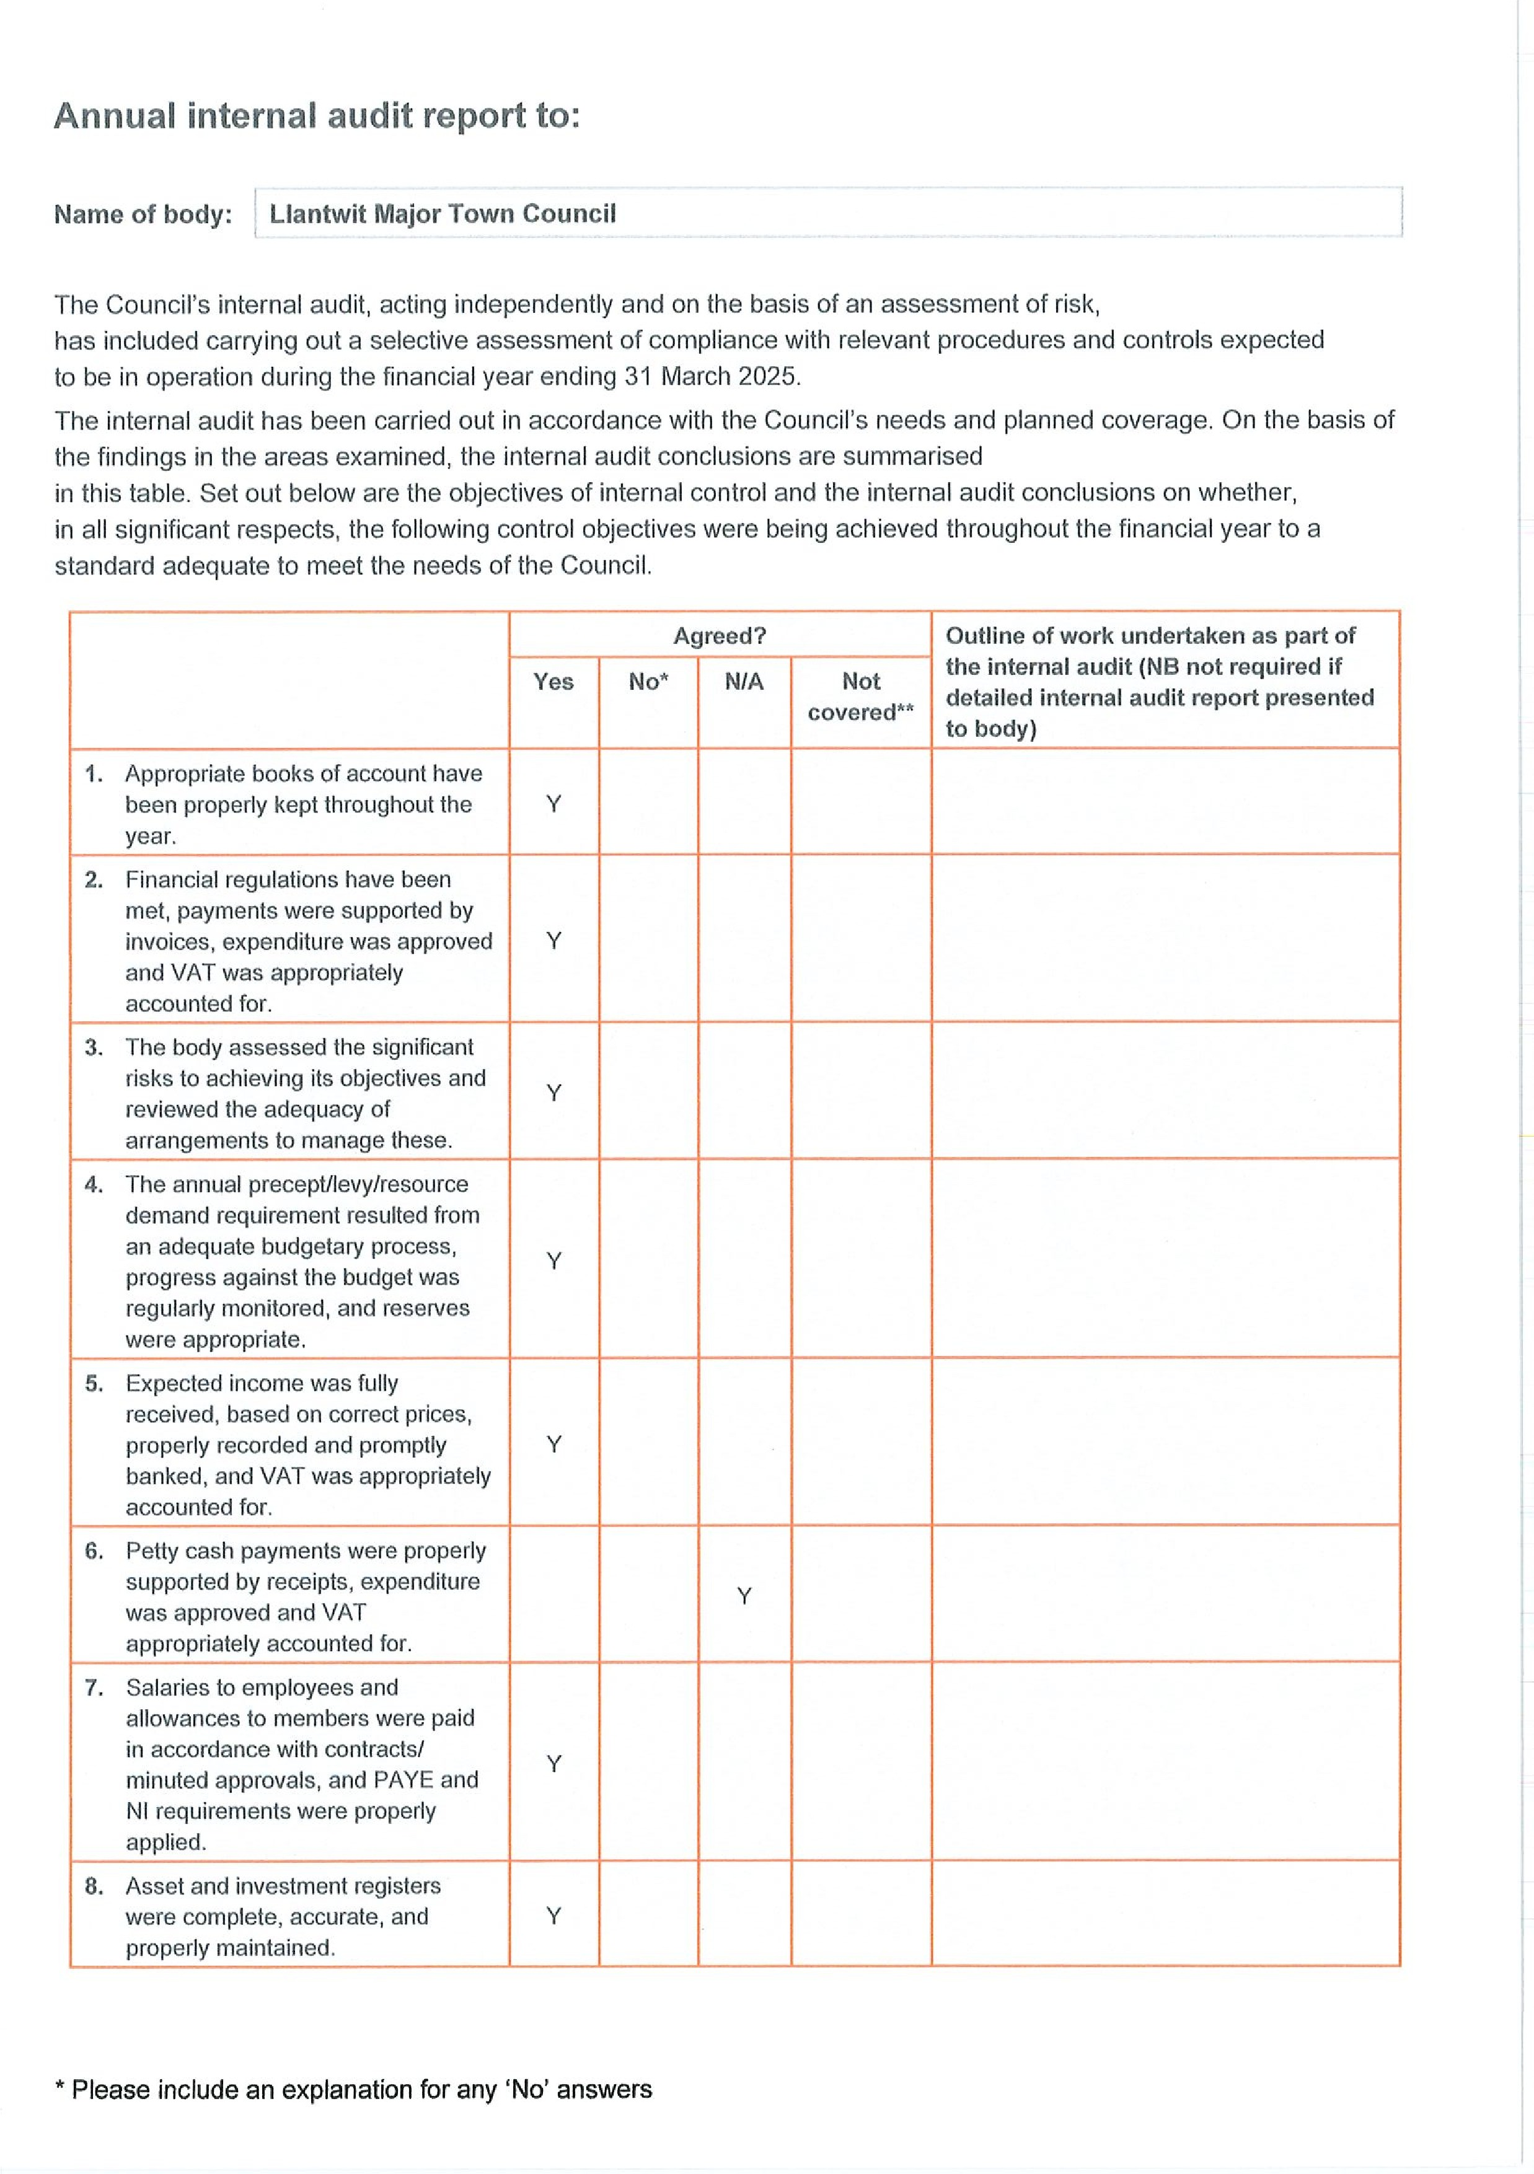
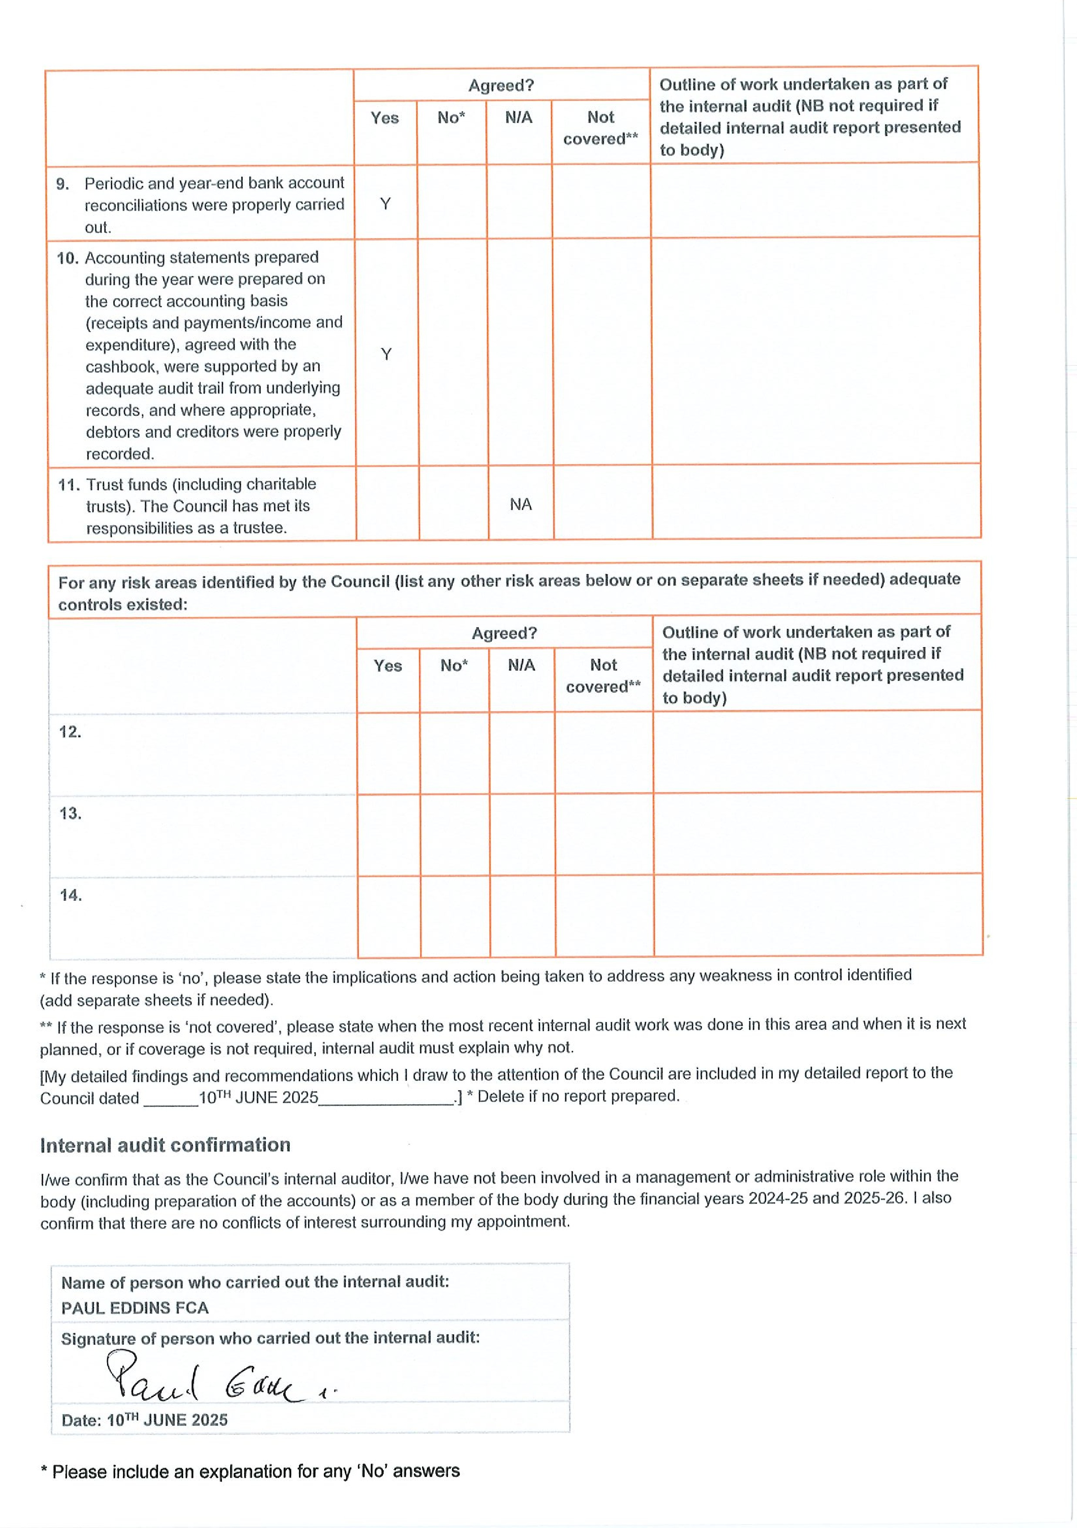
Achievements in 2025/26
Premises
- Successfully restored the hourly chime to the Town Hall clock, which had not functioned correctly for several years.
- Increased bookings and revenue from facility hire, including hosting several weddings in the Council Chamber and receptions in the Town Hall.
- Commenced installation of a new lift at the Town Hall, improving accessibility to the main hall for all users. This project is part-funded through the Placemaking Plan, The Old Town and the Strategic Placemaking Opportunities – Celebrating, Connecting and Thriving
- Secured a long-term lease on a garage storage facility, enabling efficient storage of event equipment and furniture for community use.
- Provided the Compass Building as an additional learning space for the local comprehensive school.

Stradling Park & Environmental Projects
- Officially opened the Stradling Park Community Garden in May 2025, funded through the National Lottery Heritage Fund and the Vale Local Nature Places Biodiversity Grant Scheme.
- Transformed previously unused land into an inclusive, accessible community space featuring:
  - Fruit, vegetable, and flower growing areas
  - Wildlife and biodiversity zones
  - Sensory and wetland gardens
  - Seating for learning and community activities
- Achieved a successful first harvest, with produce donated to local food banks.
- Installed a new mains water connection and column tap to ensure a reliable year-round water supply, part-funded by the Shared Prosperity Fund.

Midwell & Heritage Area
- Continued maintenance and enhancement of the area between West Street Pool and Midwell, exposing and preserving its historic significance.
- Secured funding to refurbish the Well and install a boardwalk, improving public access and visibility. Works are scheduled to commence in May 2026.
- Established a thriving biodiversity area, encouraging the return of local wildlife.
- This project is part-funded by the National Lottery Heritage Fund.

Allotments
- Continued management of 108 allotment plots, maintaining high occupancy and reducing the waiting list to just six individuals.
- Installed a new road/path at the allotment entrance, preventing vehicle damage.
- Replaced three outdated tap points with modern, weather-resistant fixtures to ensure a consistent water supply year-round.
- These improvements enhanced biodiversity, site maintenance, and resident wellbeing, with partial funding from the Shared Prosperity Fund.

Town Centre & Partnerships
- Ongoing discussions with Vale of Glamorgan Council regarding the future ownership of town centre car parks and public toilets.
- Delivered placemaking initiatives in partnership with Vale of Glamorgan Council and Studiomyco, including:
  - Extensive community consultation across all demographics
  - Adoption of a Placemaking Plan
  - Successful grant applications aligned with the plan’s priorities

Open Spaces & Recreation
- Revamped the area between the bowling green and tennis courts, creating an open, shared seating space to encourage interaction and improve the spectator experience, funded from Placemaking Plan, Community Hub and the Strategic Placemaking Opportunities – Connecting and Thriving
- Installed new inclusive piece of play equipment in the under-10s play area, part-funded by a grant from Play Wales.

Arts, Culture & Community Engagement
- Supported local artists by providing space in the Old School for classes, workshops, and exhibitions, which led to the establishment of a materials shop in the town square.
- Hosted a wide range of successful community and civic events, including:
  - Mayor’s Civic Service
  - Carols with the Councillors
  - Remembrance Day Parade
  - Community Pantomime
  - Santa’s Sleigh
- Welcomed visitors from Le Pouliguen, the town’s twinning partner, hosting a “Celebrating All Things Welsh” reception.
- Supported and assisted local groups in delivering events that attracted both residents and visitors, including:
  - Llantwit 10K
  - Christmas Light Switch-On
  - Early Voices Festival
  - Llantwit Major Chamber Music Festival
  - Come and Sing Day

Town Boost Initiative
- Successfully hosted a Town Boost event, welcoming an international guest, David Engwicht, from Australia.
- Delivered a week-long programme of workshops and community activities, culminating in a ‘one day makeover’ which saw improvements to public spaces, including repainting the old toilet block and creating a new seating area outside a local café.

2026/27 Plans and Ongoing Projects
Town Hall Improvements
- Complete and open the new lift at the Town Hall.
- Actively promote the venue to attract new hirers.
- Explore and install upgraded IT equipment to enhance usability for events and meetings.

Old School
- Improve IT provision in the Council Chamber to support hybrid meetings.

West Street Pond/Midwell Project
- Complete the Midwell project, including installation of a lectern detailing the history of the Well and Pond.
- Collaborate with the local history society to develop content.
- Consider adding a QR code linking to further historical information online.

Stradling Park Enhancements
- Build on the success of the community garden by completing final elements (e.g. installing fruit nets).
- Reconfigure and improve the pond layout.
- Develop longer-term plans for further improvements within Stradling Park.

Recreation, Open Spaces and Cemetery
- Repaint the tennis courts in August 2026 to maintain and enhance the quality of the facilities.
- Undertake tree surveys across council-managed land and complete any recommended works.
- Negotiate and formalise leases and licences with the local rugby club and bowls club.
- Undertake memorial safety testing within the cemetery.
- Complete energy audits of all council facilities to identify efficiencies and cost savings.

Community Events
- Successfully host key annual events:
  - Food Festival Weekend
  - Remembrance Day Parade
  - Pantomime

Town Centre Assets
- Finalise agreements with Vale of Glamorgan Council regarding the transfer of ownership of town centre car parks and public toilets.
- Target completion and formal sign-off by August 2026.
- Recruit and appoint a new member of staff to support these assets.

Future Infrastructure & Land Use
- Continue investigations into land availability in Llantwit Major for the development of a new cemetery.
- Progress work toward establishing a recognised public footpath along part of Mill Road.

Partnership & Placemaking
- Work closely with the Placemaking Team at Vale of Glamorgan Council to deliver further town improvements and regeneration projects.
A Prosperous Llantwit Major
What we did well
- Increase casual bookings throughout all the Town Council owned facilities.
- Long Term tenants continue their leases in the Old School eg Gillybeans (Nursery School), Bro Radio and the History Society. The Tennis Club and Bowling Club both successfully grow and prosper from their tenancy agreements with the Town Council. Additional regular hirers added to our portfolio
- Provided a temporary base for Llantwit Major Comprehensive School where they provided MCPT provision for children outside of the school environment
- WIFI facility installed in all our buildings.
- Increase in wedding ceremonies and receptions held in the Council Chamber and Town Hall Buildings.
- Stradling Park Community Garden completed and successfully used by several community groups with produce being used by the local food banks
- Finance secured for the refurbishment of Midwell and installation of a Boardwalk on the site. Project due to commence in May 2026
- The Town Council funded a Sleigh for the town to take Santa all around our Wards during the December 2025. Over 800 children/adults saw Santa during this period. Town Councillors and staff providing the necessary characters to make this a success and ensure safety of all those visiting the Sleigh
- The Town Hall Office continued throughout 2025/26 to provide information, support and tourist information to residents and visitors to the Town.
- The website is always maintained and updated in accordance with latest regulations/requirements. The online site promotes the Town Council Facilities, functions and businesses.
- Provided financial support and assistance to ensure the success of the 2025 Christmas Light Illuminations throughout the town.
- Financially supported several events within the Town including, Llantwit Major 10k, Early Voices Festival, Llantwit Major Chamber Music Festival and Come and Sing Day
- Worked closely with several departments within the Vale of Glamorgan Council to deliver projects and a successful Town Boost event which culminated in a ‘one day makeover event’ which was supported by local volunteers.

Next steps and improvements which can be made
- With the success of running Placemaking Plan and Town Boost event utilise this further to develop and enhance the working relationships with local organisations, Vale of Glamorgan Placemaking Board and encourage similar organisations to work together for the better of their town.
- Reintroduce/reinvent the Town Study Steering Group under a new name of Town Partnership where local groups, organisations and interested parties will come together to look at projects within the Placemaking Plan and how they can be taken forward.
- Continue to look at ways to use our Town Council facilities to provide community events for the town, to promote our town and increase the number of tourist and business opportunities for Llantwit Major.
- Offer our children better after school/holiday activities. For example, use Stradling Park to provide projects / extra curriculum activities for children to undertake to help with the Town Council reaching their goal of providing an eco-friendly park for the area. Also offer other local organisations and demographic groups a place where they can learn new skills, improve their wellbeing and work to help the council reach their project zero goals.
- Once the completion of the Town Hall lift, to promote the venue to attract new regular hirers.

What was said about us
“The Vale of Glamorgan Council worked in partnership with Llantwit Major Town Council to develop a comprehensive Placemaking Plan for Llantwit Major. A key element of Placemaking is embedding partnership and collaborative working between local authorities and town councils.

The Plan has now been formally adopted, and a Board has been established with representatives from the local authority and the town council. Recently 2 projects from within the Plan were given the green light to go ahead and with very short notice the Town Council has been able to bring together these Projects which will make a huge difference to the facilities and residents who use them.

Llantwit Major was one of only three Welsh towns selected to trial the One Week Town Boost, an internationally recognised revitalisation programme delivered by Creative Communities. The programme was funded by Welsh Government and supported by the Design Commission for Wales (DCFW).
It provided a high-profile opportunity to accelerate implementation of the Placemaking Plan and demonstrate tangible improvements within a short timeframe and the Town Council provided a huge support to ensure this weeklong event went smoothly”
Alec Shand (Vale of Glamorgan Officer)

“It was great to see so many volunteers, including Councillors, involved with the Town Boost this last week, and the project seems to have been a big success. Thanks to all who participated.”
Local resident via email

“Llantwit Major Bowls Club would like to thank Llantwit Major Town Council for their continued support and encouragement having provided the Town with a wonderful facility.
The Club members have also invested in the club to encourage the residents of Llantwit to not only play bowls but also join the social events e.g., Bingo, Quiz. Local Groups Probus, History Society, Llantwit in Flower, Twinning Society all enjoy the clubs excellent facilities.
All visiting bowls clubs have expressed a wish to come back to play again including County and touring teams.
None of this would be possible without the Councils and the clubs special relationship. Long may it continue”.
Bowls Club Committee members
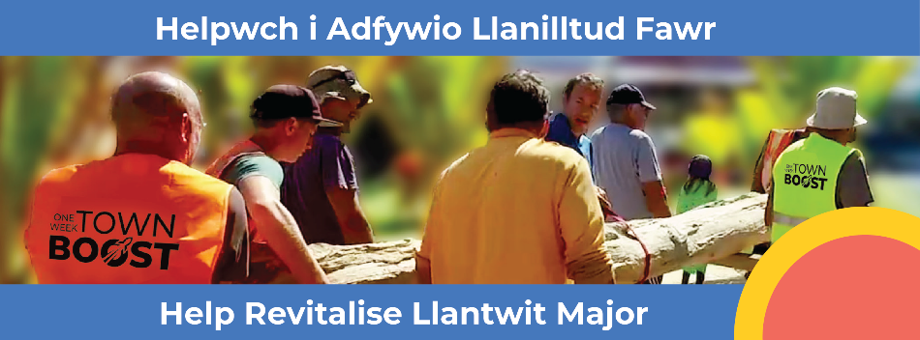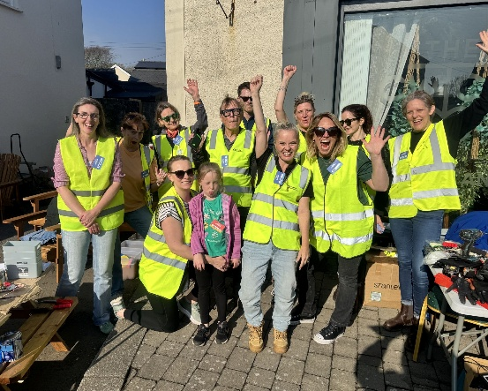

(Social media comments re Town Boost Week)
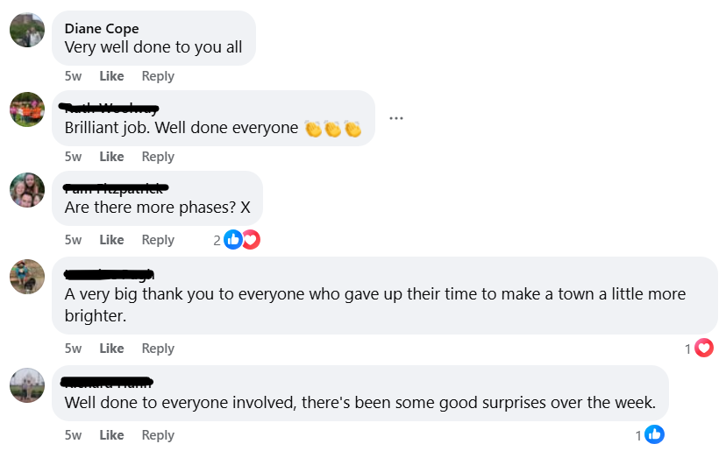
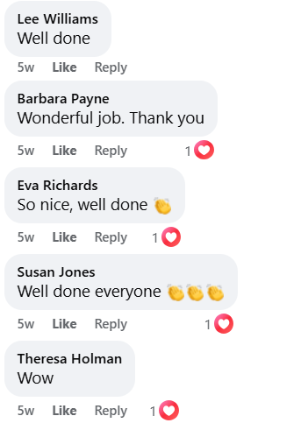

A Resilient Llantwit Major
What we did well
- The Planning Committee once again had a challenging year, with the continuation of many applications that have been sensitive in both our wards and neighbouring areas including the proposed Lidl Supermarket on the outskirts of Llanmaes. The Planning Committee adhere to the latest Welsh Government Planning Regulation Guidelines, Vale of Glamorgan Council Local Development Plan, Conservational, Ecological and Environmental recommendations whilst incorporating/listening to the views of Llantwit Major residents.
- The Planning Applications relating to TPO tagging, although not required to be reviewed by the Town Council Planning Committee, are continually checked and monitored to ensure our town is adhering to all the environmental and conservational guidelines with reference to tree preservation. The Town Council record a log of all TPO’s undertaken in the town.
- The Allotment site continues to be administered to a high level to ensure all plots are worked and maintained to standard ensuring that any which are not cultivated (if no reasons registered with the allotment committee) the tenants are evicted following a set procedure, to enable those on the waiting list the opportunity.
- The Town Council continue to safeguard and maintain Boverton Cemetery. Constantly looking for new land for a Cemetery with a limited spaces left on the existing site. Monies are budgeted and placed in to earmarked reserves each financial year, so that should land become available we are able to move quickly in purchasing, undertaking the surveys and landscaping a new Cemetery, without the need of a large PWB Loan.
- Works to Stradling Park Community Garden were completed which has resulted in several local voluntary groups and organisations cultivating the land and harvesting the produce.
- Surplus produce from Stradling Park Community Garden was donated to the local Foodbanks.
- Reduced the number of mows to all our open spaces, with surrounding areas in Stradling Park, Seaview Park and Lorna Hughes Park being left to create natural habitats for pollinators.
- Use peat-free compost as and where required
- At West Street Pond and Stradling Park 7 bird/bat boxes installed
- Application has been submitted to place Stradling Community Garden and Stradling Park within the Fields in Trust scheme, alongside the Recreation Ground, Lorna Hughes Park and Seaview Park which are already protected.
- Budget set for 2026/27 to undertake energy surveys to all our community buildings
- Green recycling bins and a composting area introduced within Boverton Road Cemetery
- Worked with local Wildfire Wales to hold 5 free events over the summer holidays for local children to attend
- Several open days held at Stradling Community Garden encouraging local residents to be involved in the garden, not only planting but being the ‘eyes’ to ensure no damage to the area
- Engaged a local arborist to undertake tree surveys within all our open spaces to allowing the Council to protect the environment by identifying valuable habitats, preventing unnecessary tree removal, managing risks from diseased trees, and informing sustainable land management.
- Cleared an area to the rear of West Street Pond which had been neglected for over 20 years and carried out tree management. Removed Leylandii and planted with native hedgerow species. Opened up the natural wetland area by excavating a deeper trench and planting native wetland plants that will attract amphibians including newts.
- Where possible all maintenance equipment used has been changed from petrol to battery operated
- The Stradling Park Community Garden Committee were shortlisted in the Community Transformation Award Category for creating the Community Garden on the site of the old Boxing Club.

Next steps and improvements which can be made
- Continue to work closely with outside parties and the local community to encourage sustainability.
- Transition vehicle toward low emissions
- Plant more native trees and hedgerows where able
- Once energy audits conducted undertake steps to reduce energy usage within the buildings
- The Town Council has been budgeting each financial year towards the purchase and landscaping of a new Cemetery. If successful in obtaining land work towards making the new Cemetery land more sustainable.
What was said about us
“I have really enjoyed being involved with the Town Council in volunteering at Stradling Park Community Garden.”.
(Community Volunteer – local resident in Fitzhamon Avenue)
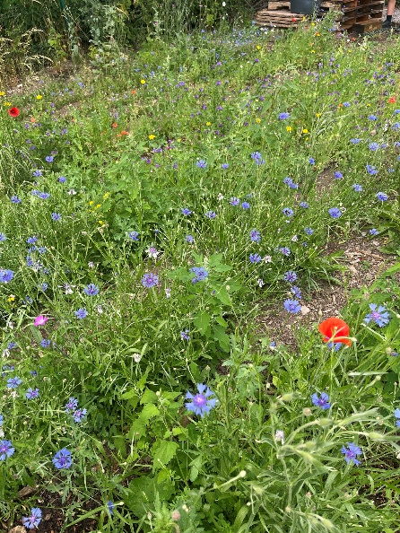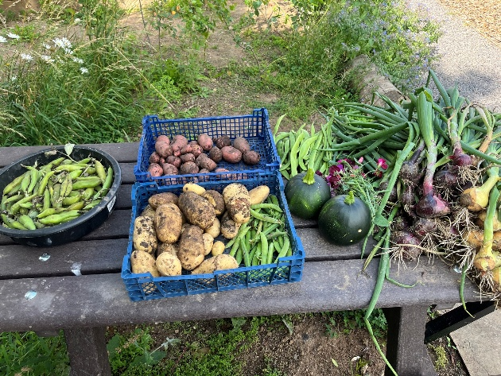
(Social media comments re Stradling Park Community Garden)
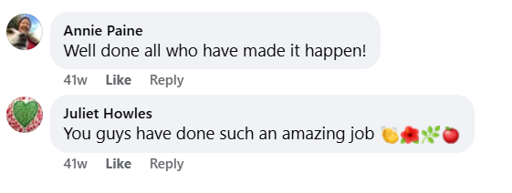
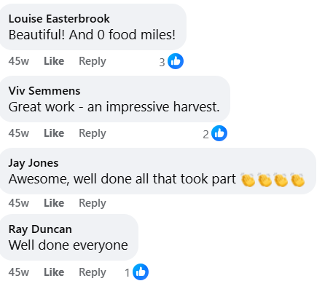
A Healthier Llantwit Major
What we did well
- Used National Lottery Funding to create Stradling Park Community Garden to encourage healthy living and improve wellbeing within the town. Ran open days at the site to educate residents on growing their own fruit and vegetables and how to landscape their gardens to enjoy the outdoors
- Held free Forest School events over the summer holidays for local children
- Maintained throughout the last year 2 play parks and adult gym equipment on the Recreations Field. Carried out annual maintenance to various pieces of play equipment following monthly inspections and installed a new piece of inclusive play equipment.
- Continued to work closely with our local sports club which use our facilities Bowls Club, Rugby Club and Tennis Club
- Started negotiations with each Club due to the legal agreements held coming to the end of the Term
- Supported the local voluntary run Llantwit Major 10K committee, increasing our Grant Aid contribution to allow them to run a 5K and 1K, which encouraged residents and children to take part
- Obtained a grant via the Placemaking/Transforming Towns to improve the area between Bowling Green and Tennis Courts, which has resulted in the removal of a diseased hedge and replacing it with sustainable fences, benches and planters. This has resulted in a viewing area for those wishing to visit the site and opened up the area, falling within our Community Hub initiative in our Placemaking Plan
- Promoted local walking groups and events held in the Town. Made available from the Town Council office local walking maps which allowed residents and visitors to walk the beautiful countryside around our Town.
- Increased our allotment plots by working with those struggling to maintain their plot
- Maintained the recreation field and all our open spaces to a standard that allows them to be used for physical activities
- Worked with the local rugby club to encourage those walking around our recreation field to pick up after their dogs to prevent infection but also to take pride in their community
- Increased wellbeing activities within our community buildings by social media promotion
- Supported groups in holding social events, coffee mornings and intergenerational activities
- Welcomed local schools to both the community garden and allotment site to promote healthy eating
- Collaborated with the local health board to undertake a survey of local residents entitled ‘Shaping Services for the Future, Together – Shaping our Future Wellbeing’
- Replaced benches that the local authority had been unable to fund but were widely used by elderly residents on daily walks
- Continue to maintain and run a Defibrillator in the Red Phone Box in the Cenotaph Square and the Defibrillator located in the Precinct.
- Continue to work towards getting the footpath officially instated along part of Mill Road, Boverton.
- We run a Footpath Forum Committee and liaise with Vale of Glamorgan Footpath Officer and neighbouring community councils re ensuring the Footpaths around area are maintained and walkable at all times.

Next steps and improvements which can be made
- Continue plans for improvements within the Community Hub
- Once lift installed in Town Hall promote this space for local groups to hire and provide classes
- Encourage more groups to become involved in the Community Garden
- Promote an environment where residents can improve both their physical and mental health
- Consider installation of a running track within the Town to support the local running community and ensure they have a safe environment in which to participate in their activity
What was said about us
“The new seating area next to the tennis courts is wonderful, can’t wait for the sun to come out and sit there where I can watch tennis one side and bowls the other. Thank you to the Town Council and Placemaking Team who pulled this project off in less than 3 months, what an achievement’
(Tennis club member)

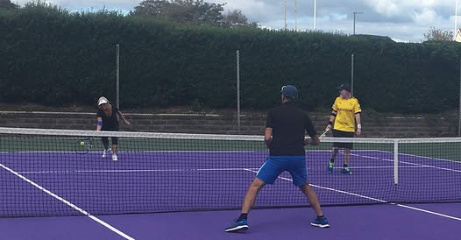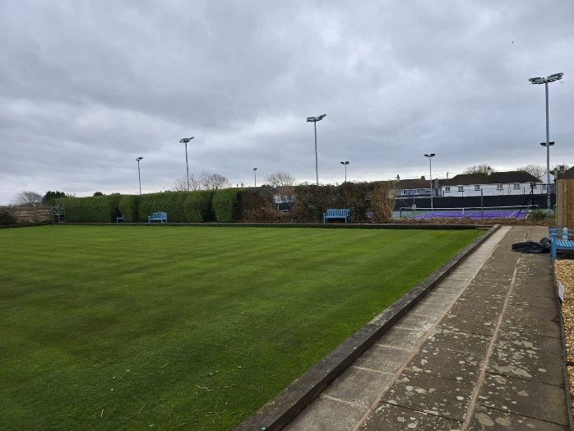

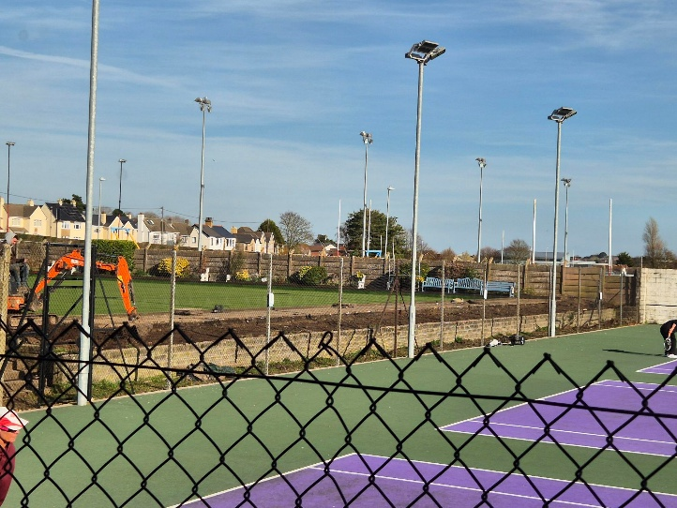
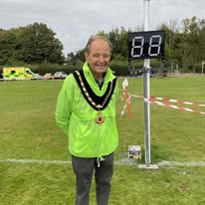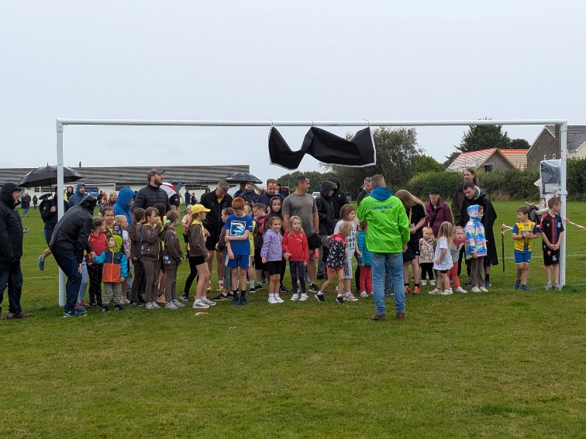
A More Equal Llantwit Major
What we did well
- The Town Council successfully awarded grants to the following local groups to provide additional funds for them to maintain and run their organisations. Grants for 2025/26 were awarded to:-
- Llantwit Major Christmas Illuminations Committee
- Llantwit Major 10K Committee
- Llantwit Major Chamber Music Festival
- Early Voices
- Llaniltud Fawr in Flower
- Memory Café
- St Donats Chorale
- Valeways
- Ageing Well group
- Hosted several successful events, free or at a low cost, for residents or visitor to Llantwit Major
- Sleeping Beauty Pantomime
- Santa Sleigh
- Carols with Councillors at The Cenotaph
- Forest Schools
- Community open days
- Remembrance Parade
- VE Day 80 events including Lighting of Beacon and Proclamation
- Town Mayors charity quiz night and bingo
- The Town Council have supported the Town Mayor, Councillor John Deakin with his chosen charity, raising over £1,700 during his term in Office.
- Reduced rates are given to local groups which use our community building, providing support to the elderly, low income and children with additional needs.
- Successful grant application to install a new piece of inclusive play equipment within the under 10’s playarea
- Resurfaced the entrance path into the allotments to allow easier access for those with limited mobility.
- Surplus produce from Stradling Park Community Garden was donated to the local Foodbanks.
- Ensured translation facilities are available if requested
- Hosted a consultation event with Head of Strategic Partnerships and Engagement, Cardiff and Vale UHB, who undertook a listening exercise in relation to their ten-year clinic services plan and its engagement approach.
- Offered a facility to a group who have been developing courses for young people, to help build their confidence, their communication skills and also to give them the opportunity to have their voices heard on the radio across the Vale of Glamorgan
- Worked with local comprehensive school to provide a building where young people are able to attend courses outside of the school academic curriculum
- Updated our EDI Policy and all staff and Councillors attended a training course
- The Town Council has improved access to services and supporting residents facing financial hardship. The Council is working to reduce inequalities and enable all residents to fulfil their potential regardless of their background or circumstances
- The Town Council has successfully secured grant funding to install a lift within the town’s historic building, enabling step-free access to the first-floor main hall. This improvement will significantly enhance accessibility for disabled people and those with mobility needs, ensuring the building can be enjoyed by a wider range of residents. The project will both increase use of the facility and support the preservation of an important community asset by making it inclusive and accessible to all
Next steps and improvements which can be made
- Be more proactive in hearing from young people, older residents, disabled people, minority groups
- Strengthen local connections to reduce the impact of financial hardship on our residents
- Improve lighting in and around our facilities
- Continue to replace play equipment with inclusive equipment
- Work towards all the recommendations within our DDA report for the Town Hall/Town Council offices
- Update our hybrid meeting equipment to allow for more accessible ways for residents, and Town Councillors, to engage with the Town Council during our meetings

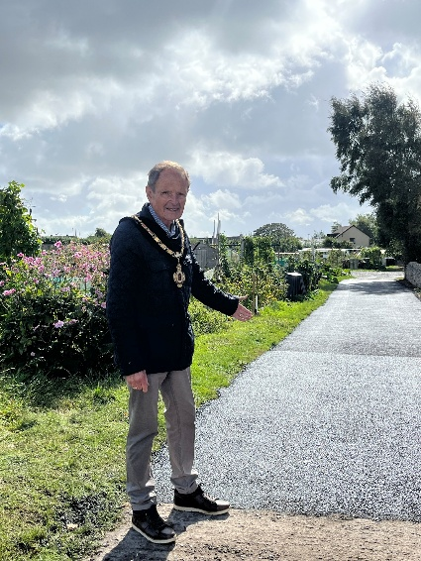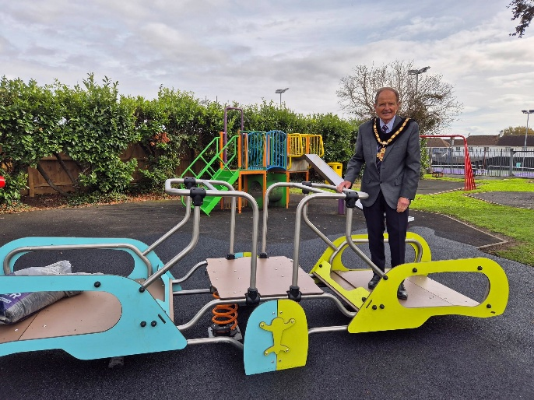

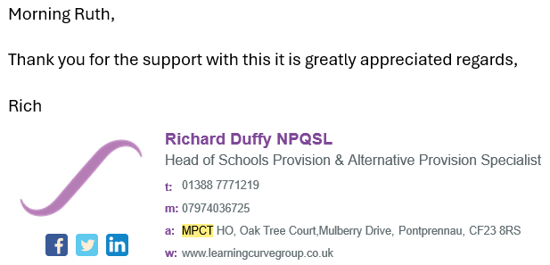

(Social media comments re local events)
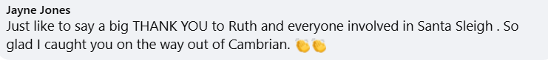
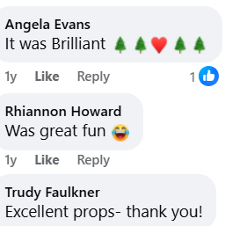
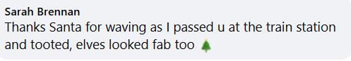
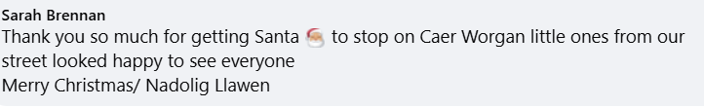

A Cohesive Llantwit Major
What we did well
- Our Buildings provide a base for multiple organisations/groups for our town, including a nursery, art groups, radio studio, Age Connect, line dancing, yoga, tai chi, history society, horticultural society, sports clubs, birthday parties, wedding services and social events as well as our Town Council office and Council Chamber.
- Worked alongside a group of volunteers during the Town Boost week to enhance our town centre to improves it appearance and provide an attractive, welcoming place
- Provided financial support to Llanilltud Fawr in Flower, a local volunteer orgnaisation which plant and maintain the planters and flower beds in the Town Centre
- Continued to maintain our 4 open spaces to a high standard with daily litter picking and bin collections
- Maintained a good relationship with our local Police Community Constable providing administrative support for their local Pubwatch initiative
- Worked with the Vale of Glamorgan Council to install new lighting in a local car park, and refurbishment of a toilet block, both of which we will being taking over on a long-term lease in the near future
- Supported Llantwit Major 10K and Llantwit Major Christmas Illuminations Committee, financially, administrative assistance and stewarding at the events. These events brought residents together and strengthened local connections
- Continued to lobby Vale of Glamorgan Council to reintroduce a road sweeper to our Town, following the removal of this service several years ago. Confirmed that a new role will be created during 2026, with the Town Council playing a role in given instruction to the operative on where works required
- Provided additional seating within the Town
- Initiatives from our hirers to reduce isolation and promote inclusive community participation was supported both financially and with manpower where needed
- Partnership workings were strengthened and our good working relationship maintained with the Vale of Glamorgan Council, Police, community groups and the local health service
- Continued our call for an increase in train services to the Town, lobbying Senedd Members, Members of Parliament and Transport for Wales to provide a better service for our residents, an hourly train service with 2 carriages, and a last train at 2240hrs is not acceptable for such a large thriving Town.
- Campaigned for better transport links for the whole of the rural Western Vale.
- Worked alongside and hosted quarterly meetings with the local Rights of Way Officers to improve and continue to maintain the rural footpaths and bridleways in our Town
- Adopted Llantwit Major Place Making Plan. Two Town Councillors and the Town Clerk sit on the Llantwit Placemaking Board to implement the recommendations within the Plan
- We worked closely with Fields in Trust to safeguard 2 of our Open Spaces. This will ensure that everyone – young or old, able or disabled, will have access to free, local outdoor space for sport, play and recreation. These spaces are vital to building happy and healthy communities and sadly continue to be threatened by all kinds of development.
- For the second year the Town Council employed gardener/handyperson met local school children at the allotment site and walked them around discussing and sampling local produce.
- Members closely monitor the way the Council is run to ensure we use our resources wisely.

Next steps and improvements which can be made
- Reestablish the Town Study Steering Group under the new title Town Partnership where interested parties will be invited to a quarterly meeting to put forward their ideas and suggestions on how the Town can be improved and developed in the future
- Continue to maintain our public open spaces
- Encourage and work with local businesses to reinstate the Chamber of Trade
- Push for the local authority to improve the pavements within the Town which are falling into disrepair
- Look at ways to assist businesses to promote footfall and tourism our town.
- Produce promotional materials outlining the difference between the Town Council and Vale of Glamorgan Council and highlighting the services each Council provides

What was said about us
“Would like to thank Llantwit Major Town Council for all their support in my role as the local Community Constable, LNP Team.”.
(PC Jamie Williamson)

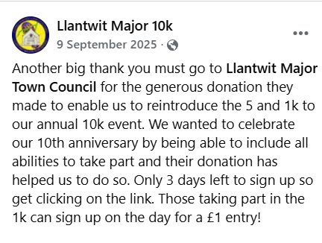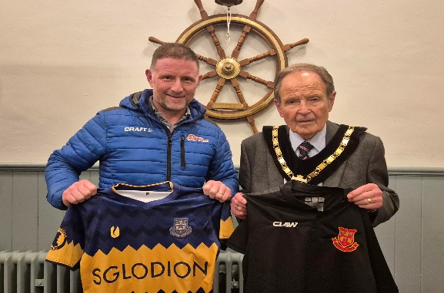

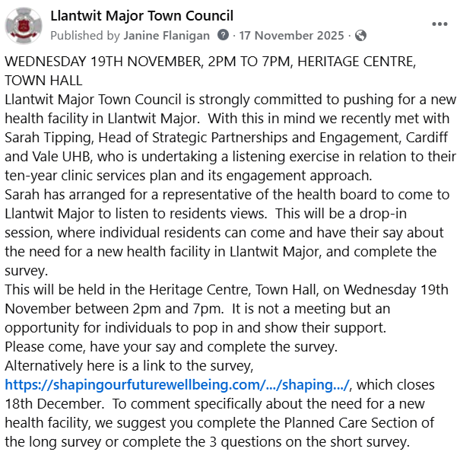

A LLANTWIT MAJOR OF VIBRANT CULTURE AND THRIVING WELSH LANGUAGE
What we did well
- Continual maintenance of our listed buildings adhering to CADW guidelines. Following years of negotiations, work has commenced on the installation of a lift in the Town Hall which will enable the main hall to be accessible for those with limited mobility for the first time.
- Negotiations have started with the Conservation Officer and CADW to look at replacing or refurnishing existing doors on the Town Hall.
- The Cenotaph is cleaned four times a year to preserve and maintain this historic monument.
- Welcomed our friends from Le Pouliguen with the Town Mayor hosting a reception in the main hall, Town Hall. This was a celebration of all things Welsh, and included a traditional feast of Leek soup, Lamb Cawl, Welsh Cheese and Bara Brith. A local violinist entertained with classic Welsh folk songs and also an impromptu set of requests from those present
- All new signage produced bilingually in Welsh and English.
- The Council is committed to promoting equality, inclusion and the Welsh language in accordance with the Equality Act 2010 and Welsh Language Standards
- Organised Remembrance Day Parade and Service to mark Remembrance Sunday, along with a smaller Service to commemorate Remembrance Day
- Working with local History Society to look for new premises to house their archive room due to growing membership and the many resident who visit the room
- Council Meetings poster is produced bi-lingual and all agendas, minutes and reports on request can be translated to Welsh.
- Incoming telephone calls to the Town Council offices are answered in both Welsh and English.
- Our Welsh Language Scheme is continually reviewed and amended when required.
- Town Hall has external lighting which enables us to highlight the historic building but also change its colour to reflect celebrations, events and awareness
- Historic Town Hall clock and bell now fully operational, which will enable us to know look at reinstating the Dragon weathervane
- Successfully secured grant funding to install a lift within the town’s historic building, enabling step-free access to the first-floor main hall. This improvement will significantly enhance accessibility for disabled people and those with mobility needs, ensuring the building can be enjoyed by a wider range of residents. The project will both increase use of the facility and support the preservation of an important community asset by making it inclusive and accessible to all.
- Repairs to windows at the Old School due to storm damage
- Continued maintenance and enhancement of the area between West Street Pool and Midwell, exposing and preserving its historic significance
- Secured funding to refurbish the Well and install a boardwalk, improving public access and visibility. Works are scheduled to commence in May 2026.
- Supported local artists by providing space in the Old School for classes, workshops, and exhibitions, which led to the establishment of a materials shop in the town square.
- Interpretation boards purchased to be placed at West Street Pond highlighting it significance
- Provided financial support for several events which highlighted local cultural initiatives
Next steps and improvements which can be made
- Town Councillors and staff try to improve their knowledge and use of the Welsh language
- Increase support for arts and creative industries
- Promote heritage tourism and local identity
- Continue works on the installation of lift within the Town Hall
- Restore the ceiling artwork left from the Oddfellows, in main hall, Town Hall
What was said about us
“Had such an amazing night, thank you for inviting me along to play at your Town Twinning reception. Was wonderful to see so many people joining in singing and to be asked to play traditional Welsh folk songs was an exciting challenge for me.”
(Clarke Alonzi)

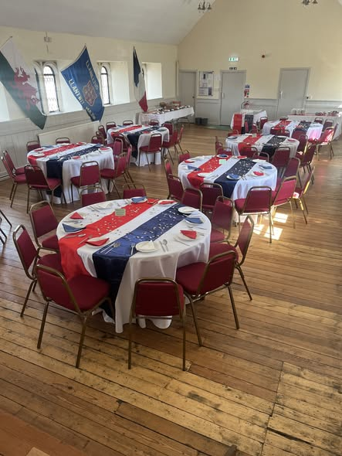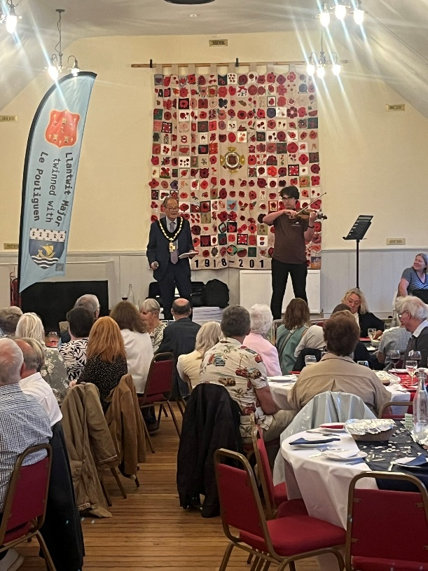
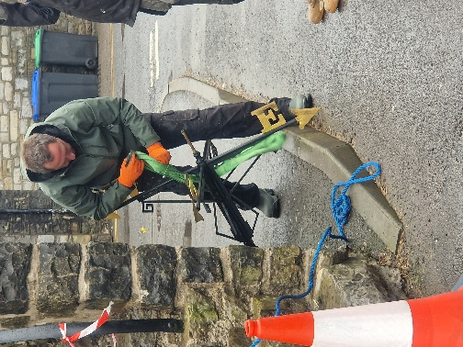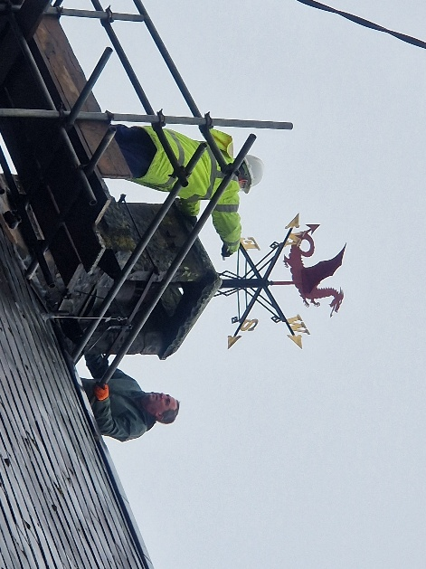
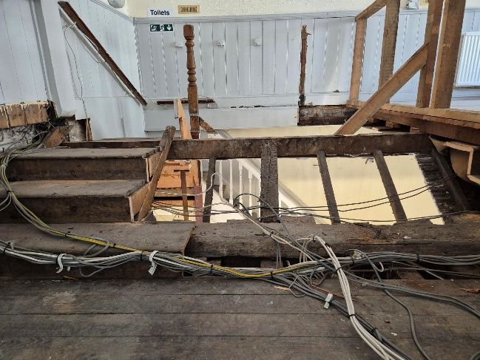
A Globally responsible Llantwit Major

What we did well
- Produce and continually review our Biodiversity and Resilience of Ecosystems Duty Report 2025 and Policy.
- We have provided green recycling facility at our Cemetery, as well as a compost area
- At all our events we ensure we have individually labelled recycling bins available for all to dispose of their waste
- Within our hiring agreement we ask hirers to ‘think’ about the party tableware, plates, straws, cups etc and where possible use recyclable produces and no single use items
- When setting the budget for 2026/27 included has been the provision to look at costings for undertaking energy audits for all our premises
- New trees quicks have been planted within Stradling Garden
- A tree survey will be undertaken in the summer of 2026 and any which need removing will be replaced with a native tree
- Our tree policy was updated and residents who wrote to the Council applying to remove trees from our joined boundaries were asked to look at alternative solutions
- We are working with The Vale of Glamorgan Local Nature Partnership Officers to work on two major projects Midwell/West Street Pool and Stradling Park to enhance an increase biodiversity in the two areas.
- Have allocated 3 plots within its open spaces where wildflowers are cultivated and sewn each year. We provide suitable and appropriately managed habitats for protected species where appropriate and ensure no negative impact on protected species and the environment.
- Manage our wooded and hedgerow areas to encourage biodiversity.
- Maintain historical stone memorials to protect lichen growth.
- Where possible our contracts are awarded to local contractors thus reducing our carbon footprint traveling to and from sites
- All street furniture when replaced or procured are made from recyclable materials
- Started work within both Stradling Park and Lorna Hughes Park introduced hedgehog highways to ensure they have a safe route to and from known nesting and feeding areas.
- Councillor representative sits on the local Fairtrade Group and as a Town Council we serve Fairtrade tea, coffee and sugar at events
- We lift and store for future planting from our flower tubs around The Square and encourage Plant Swaps at our open days at Stradling Garden
- We are working with the Vale of Glamorgan Council on their Project Zero goals
- Ground maintenance equipment has been replaced by battery operated equipment where possible
- Bonfires have been banned from our allotment site
- Stradling Park and the Allotments both have rain collecting facilities, but we were successful in a Stronger Communities Grant application this year and were able to replace the old less then efficient taps at the Allotment site with new ones, and install a new water supply to the Stradling Garden, although this is only to be used if the rain collecting tanks run dry
- All our open spaces are protected under the Fields In Trust Scheme
- Encouraged Councillors to go paper free where possible in receiving their meeting paperwork
- We are a Refill town

Next steps and improvements which can be made
- Implement recommendations from the energy audit, as far as practicle
- Reinstate any trees which must be felled following the tree audit
- Formulate plans for Stradling Park including wildflower area, allowing the edges to become rewilding areas and thus encouraging wildlife to thrive
- All meeting paperwork to be only available online and no longer print out

What was said
‘ Having access to the community garden has been a game changer for my gardening work with adults with additional needs. Our allotment was only really suitable for those who have good mobility, limiting what is a fantastic all round activity which benefits everyone. Wheelchair users can now have full access to everything alongside new friends and members of their community thanks to the community gardens. I have had a more enthusiastic attendance week on week, my only problem now is everyone just wants to be at the community garden and not the allotment. It is a valuable space for us’
(Karen Christie – Cartrefi)

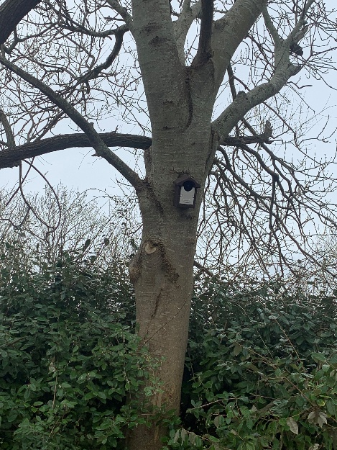
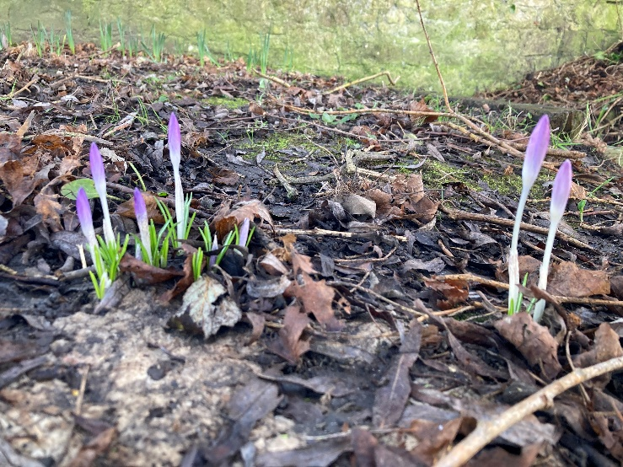
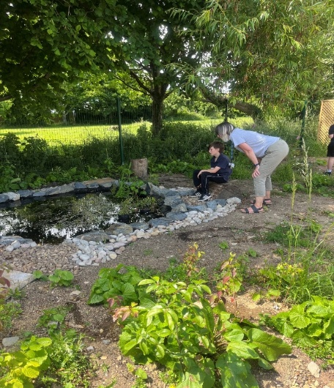

PLACEMAKING
What is Placemaking
Llantwit Major Town Council, working in partnership with the Creative Communities team, Vale of Glamorgan Council, launched the Llantwit Major Placemaking initiative in 2023.

Over the next two years, a programme of engagement events was held inviting residents, businesses, and community stakeholders to share their ideas and aspirations. These conversations captured what matters most to the people who live, work, and visit Llantwit Major, helping to shape a shared vision for the town’s future.

The main themes that emerged from this engagement, included:
- Celebrating - this means making the most of Llantwit’s amazing history, nature and culture
- Connecting - about making sure places in the town are easy for everyone to get to and enjoy
- Thriving - this aims to support local businesses and help the community stay strong, healthy and full of life for the future.

Principles of Placemaking
The Placemaking Wales Charter has been developed and includes six placemaking principles:
- People and Community - The local community are involved in the development of proposals. The needs, aspirations, health and well-being of all people are considered at the outset. Proposals are shaped to help to meet these needs as well as create, integrate, protect and/or enhance a sense of community and promote equality
- Location - Places grow and develop in a way that uses land efficiently, supports and enhances existing places and is well connected. The location of housing, employment leisure and other facilities are planned to help reduce the need to travel.
- Movement - Walking, cycling and public transport are prioritised to provide a choice of transport modes and avoid dependence on private vehicles. Well designed and safe active travel routes connect to the wider active travel and public transport network, and public transport stations and stops are positively integrated.
- Mix of uses - Places have a range of purposes which provide opportunities for community development, local business growth and access to jobs, services and facilities via walking, cycling or public transport. Development density and a mix of uses and tenures helps to support a diverse community and vibrant public realm.
- Public Realm - Streets and public spaces are well defined, welcoming, safe and inclusive with a distinct identity. They are designed to be robust and adaptable with landscape, green infrastructure and sustainable drainage well integrated. They are well connected to existing places and promote opportunities for social interaction and a range of activities for all people.
- Identity - The positive, distinctive qualities of existing places are valued and respected. The unique features and opportunities of a location, including heritage, culture, language, built and natural physical attributes, are identified and responded to.
The plan can be accessed via (we are currently updated our website to include a Placemaking page)
https://participate.valeofglamorgan.gov.uk/llantwit-major-placemaking/news_feed/llantwit-major-placemaking-plan-has-been-published
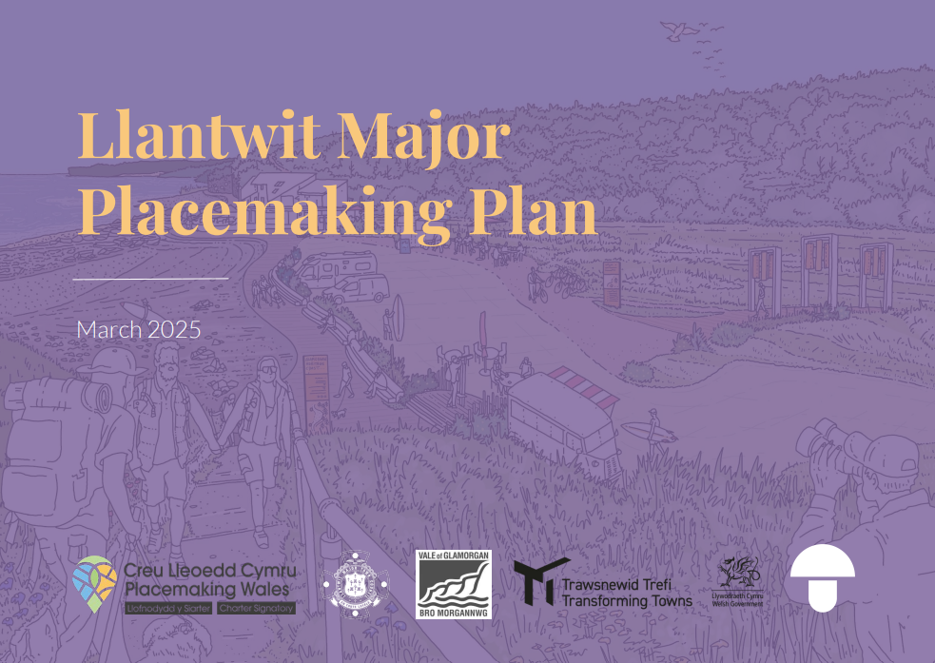

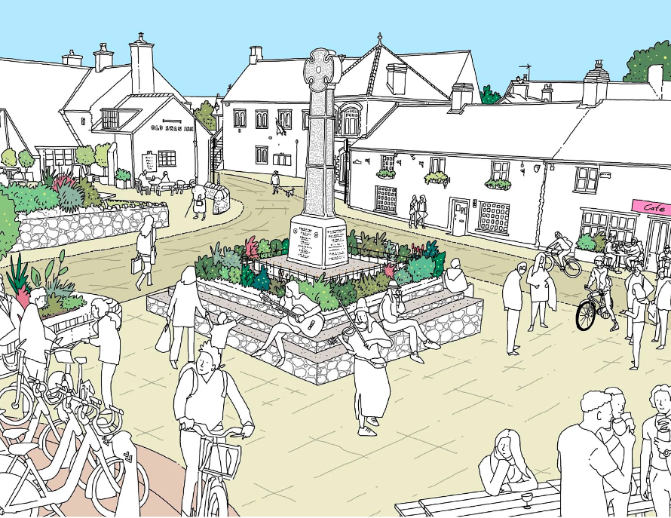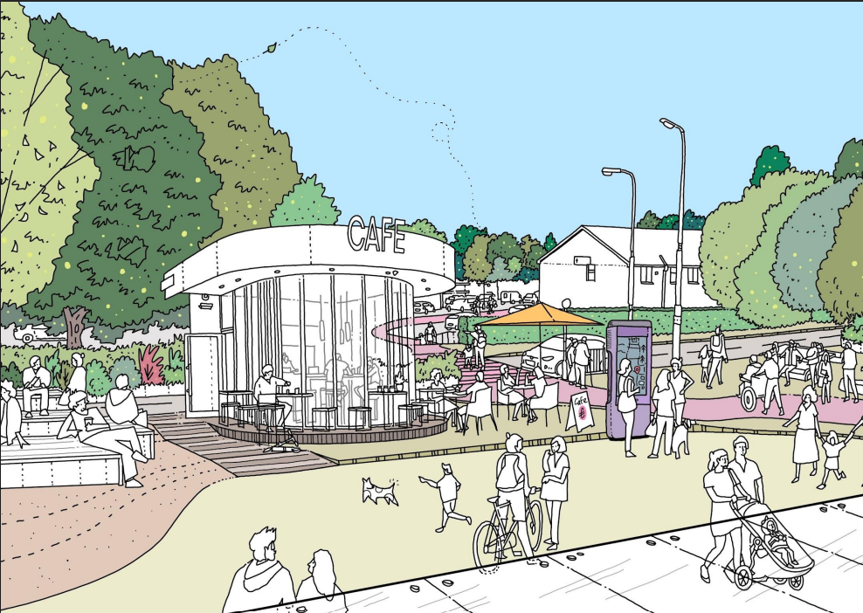

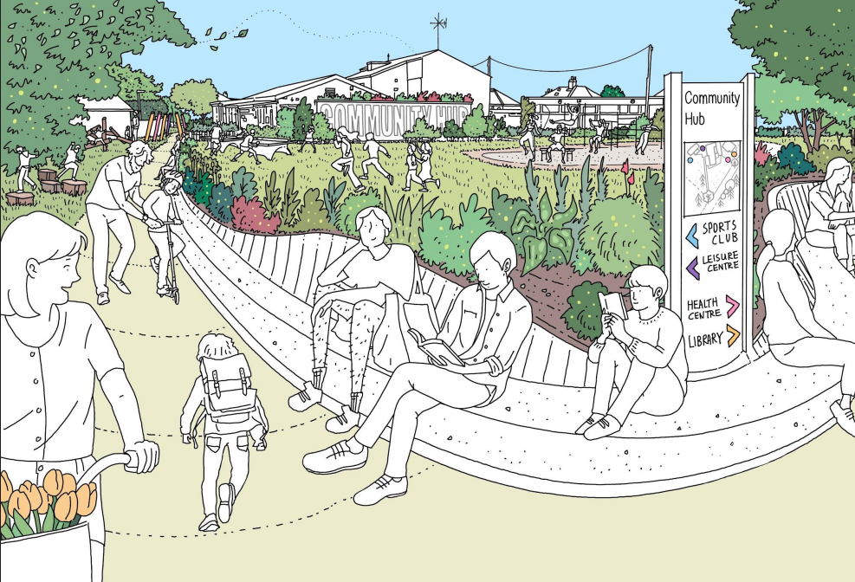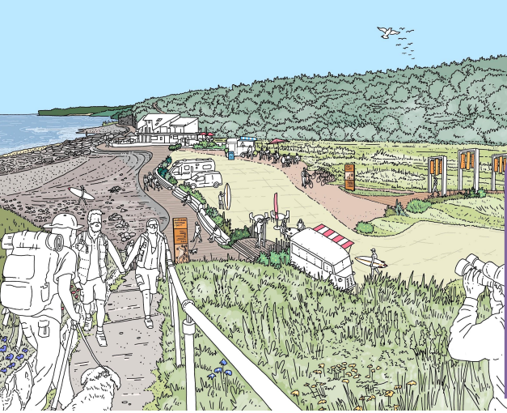

PROJECT PICTURES
Midwell project
,, 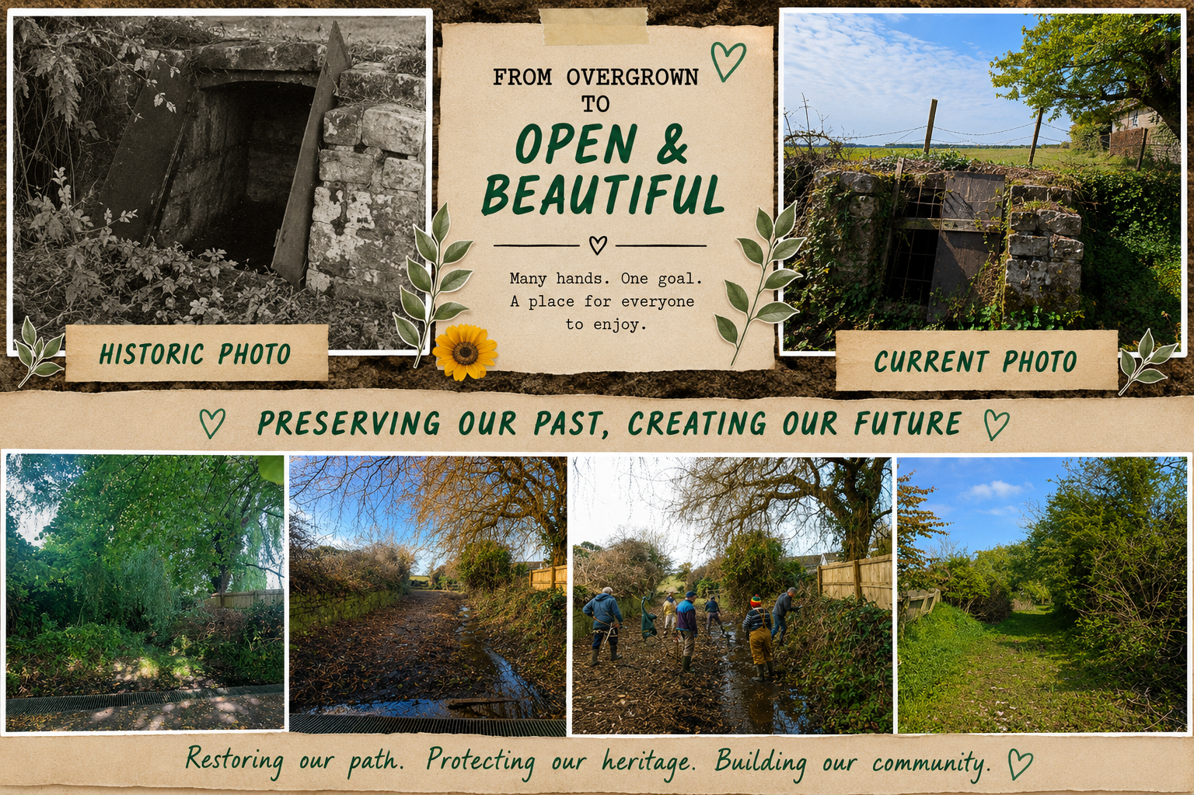

Stradling Community Garden
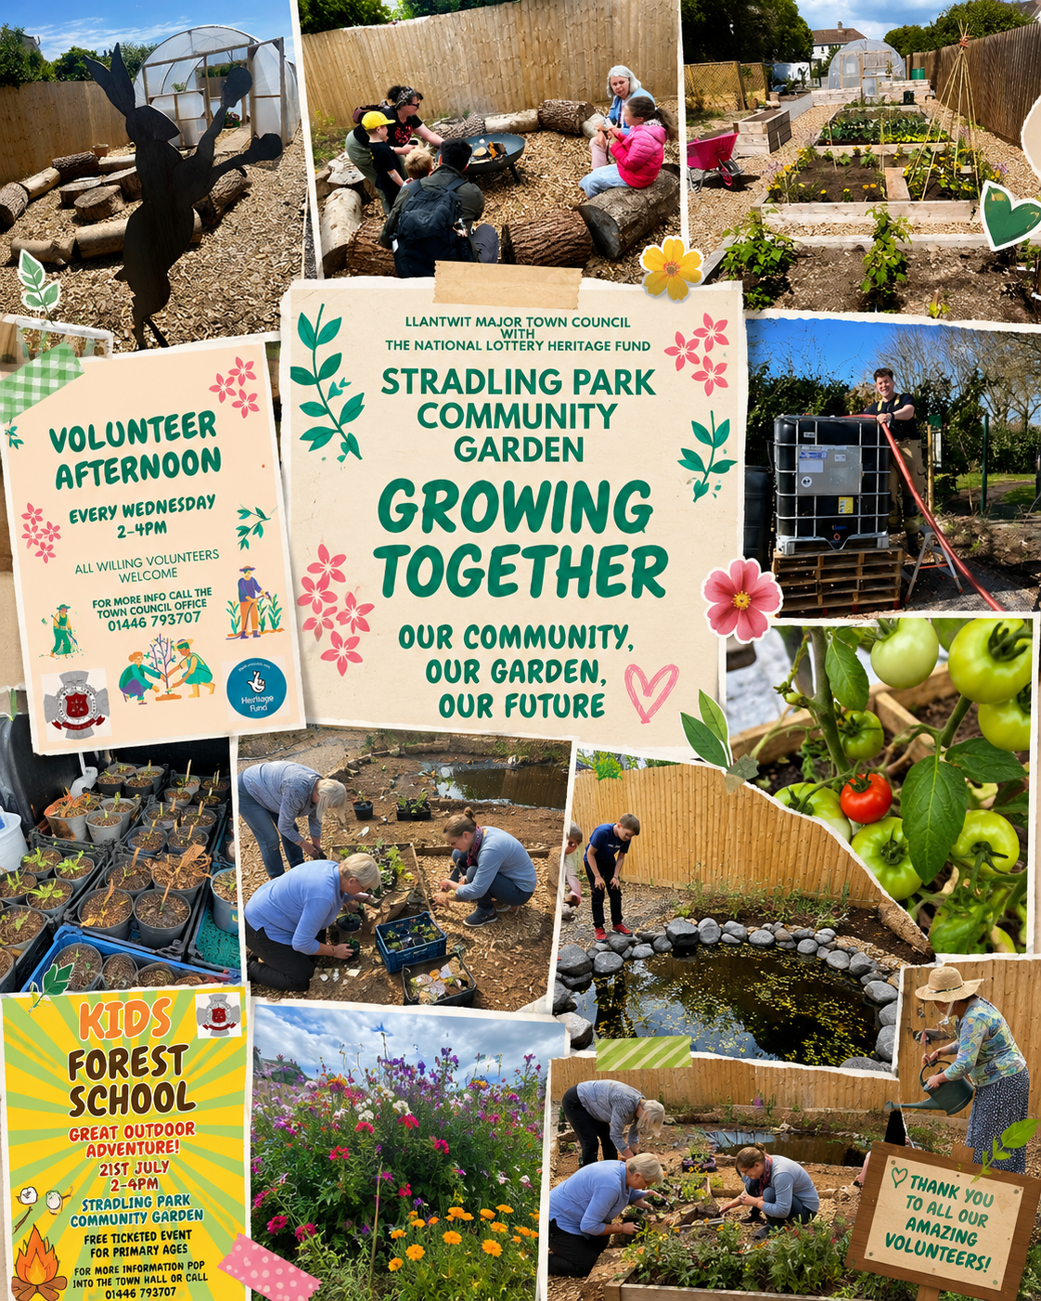

Town Hall lift
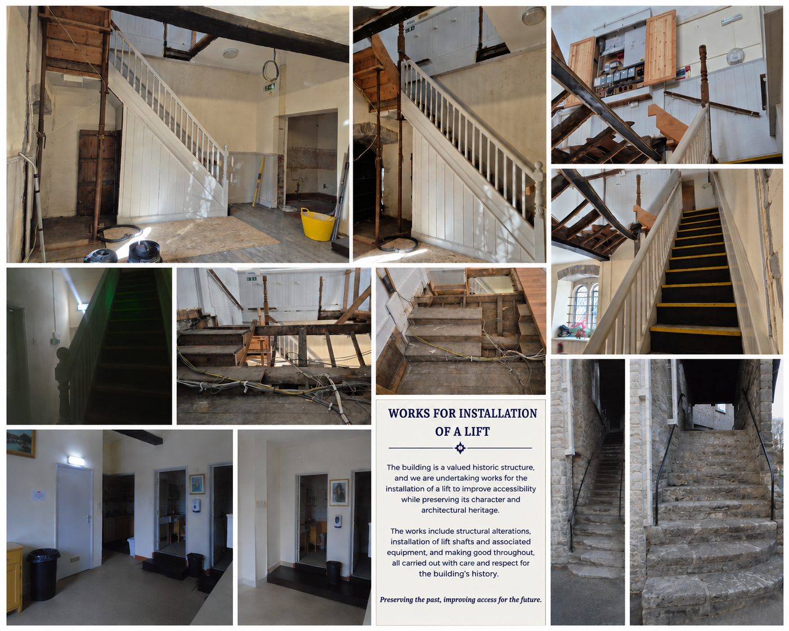
Community Hub Project
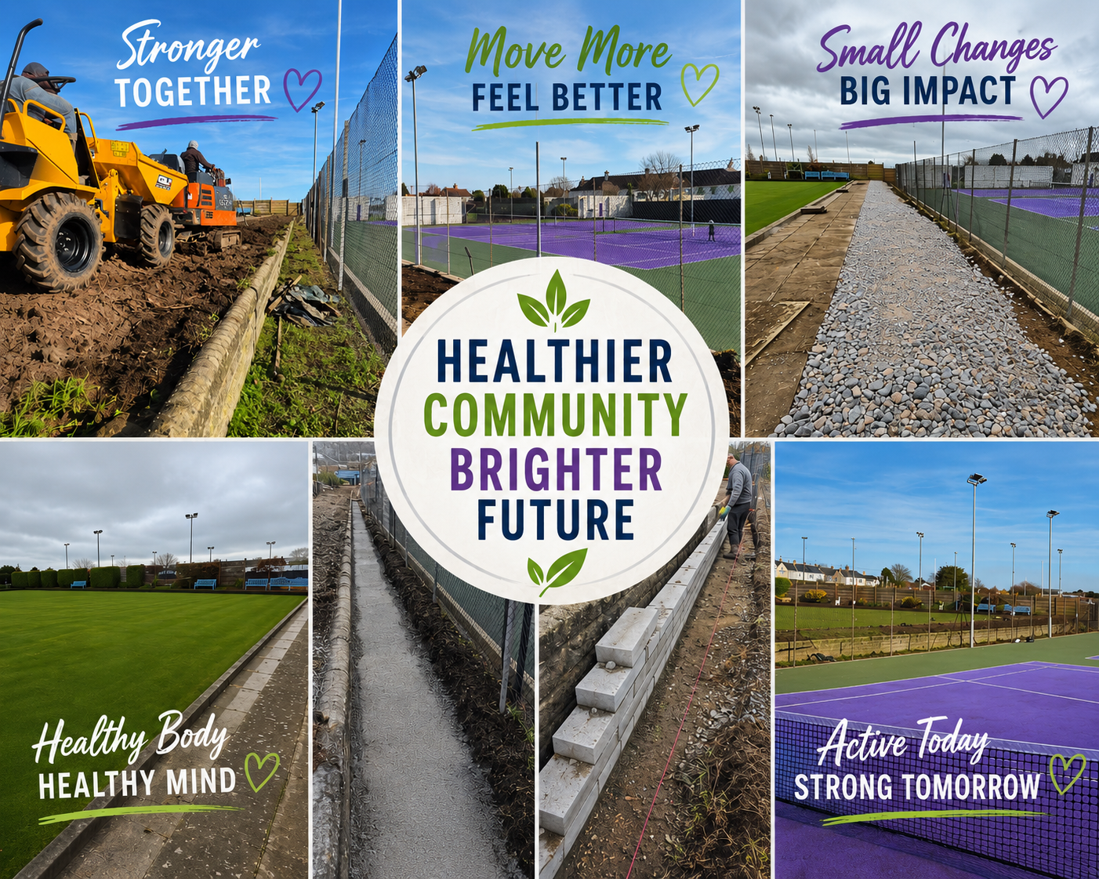
Town Boost Week
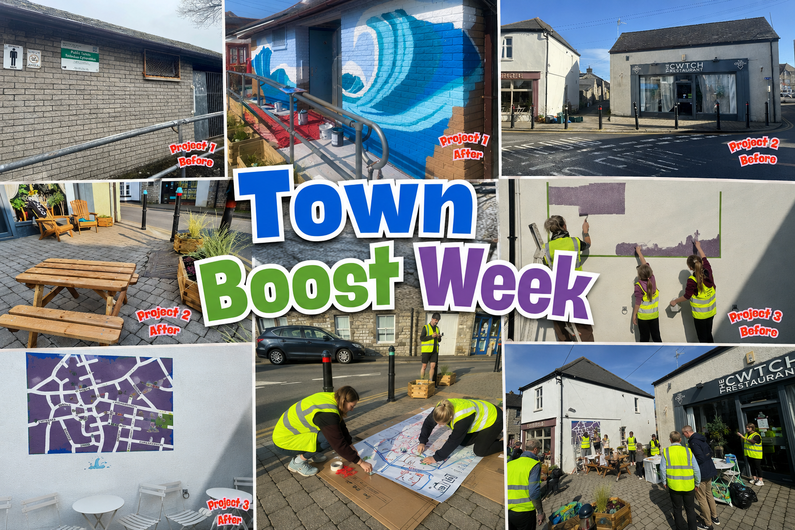

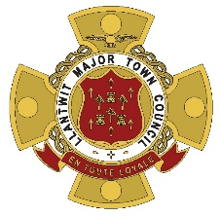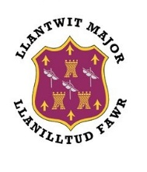

CONTACT US

The Town Council offices are located in the Town Hall, Church Street, Llantwit Major, CF61 1SB.

Office opening hours are Monday to Friday 9.30am until 1pm.

Alternative methods of contact are

Telephone: 01446 793707 (Monday to Friday, 9.00am to 1pm and 2pm to 4pm)
Email : info@llantwitmajortowncouncil.gov.uk

Please contact us and we arrange to meet outside of the office hours if required.

